Again need the length of the carbon fiber tubes.

Wing Assembly
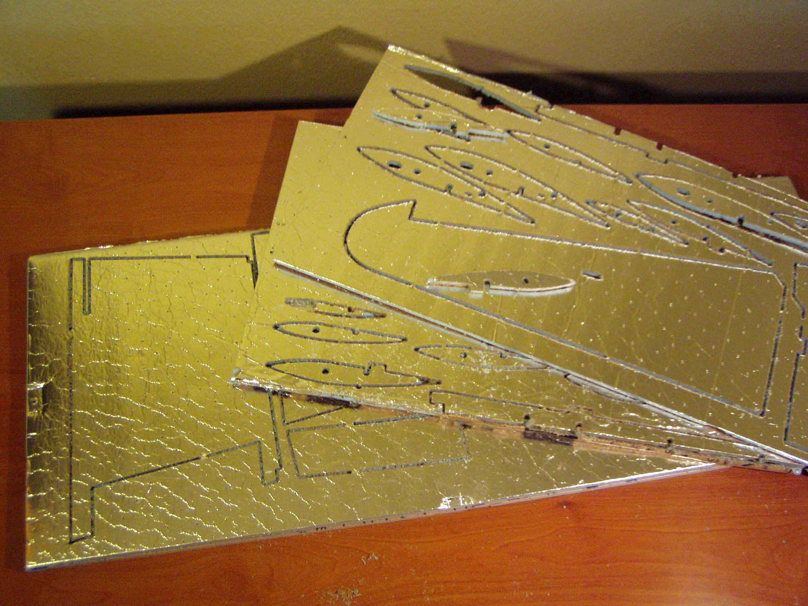
Grab the sheets for the wing and punch out all of the parts. There are four sheets. Two with the bottom wing panels and the ribs and a couple more with the upper wing panels and ailerons.
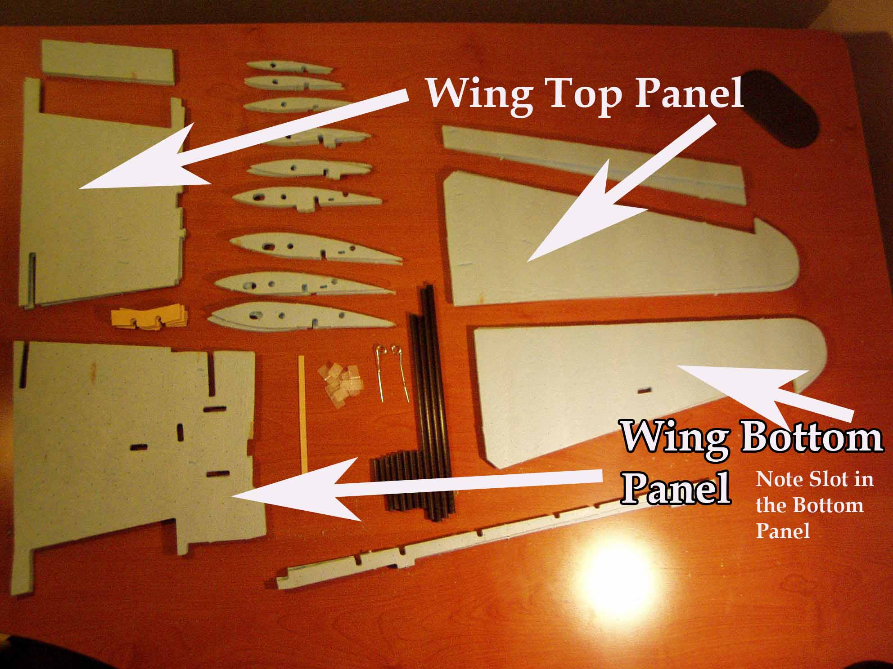
Identify all of the parts required to build the wing. There are two of each foam part. Important things to note in assembling the wing—be sure to build a right and a left wing panel, and be sure to use the top wing panels on the top and the bottom wing panels on the bottom. The bottom wing panels have more slots cut in them.
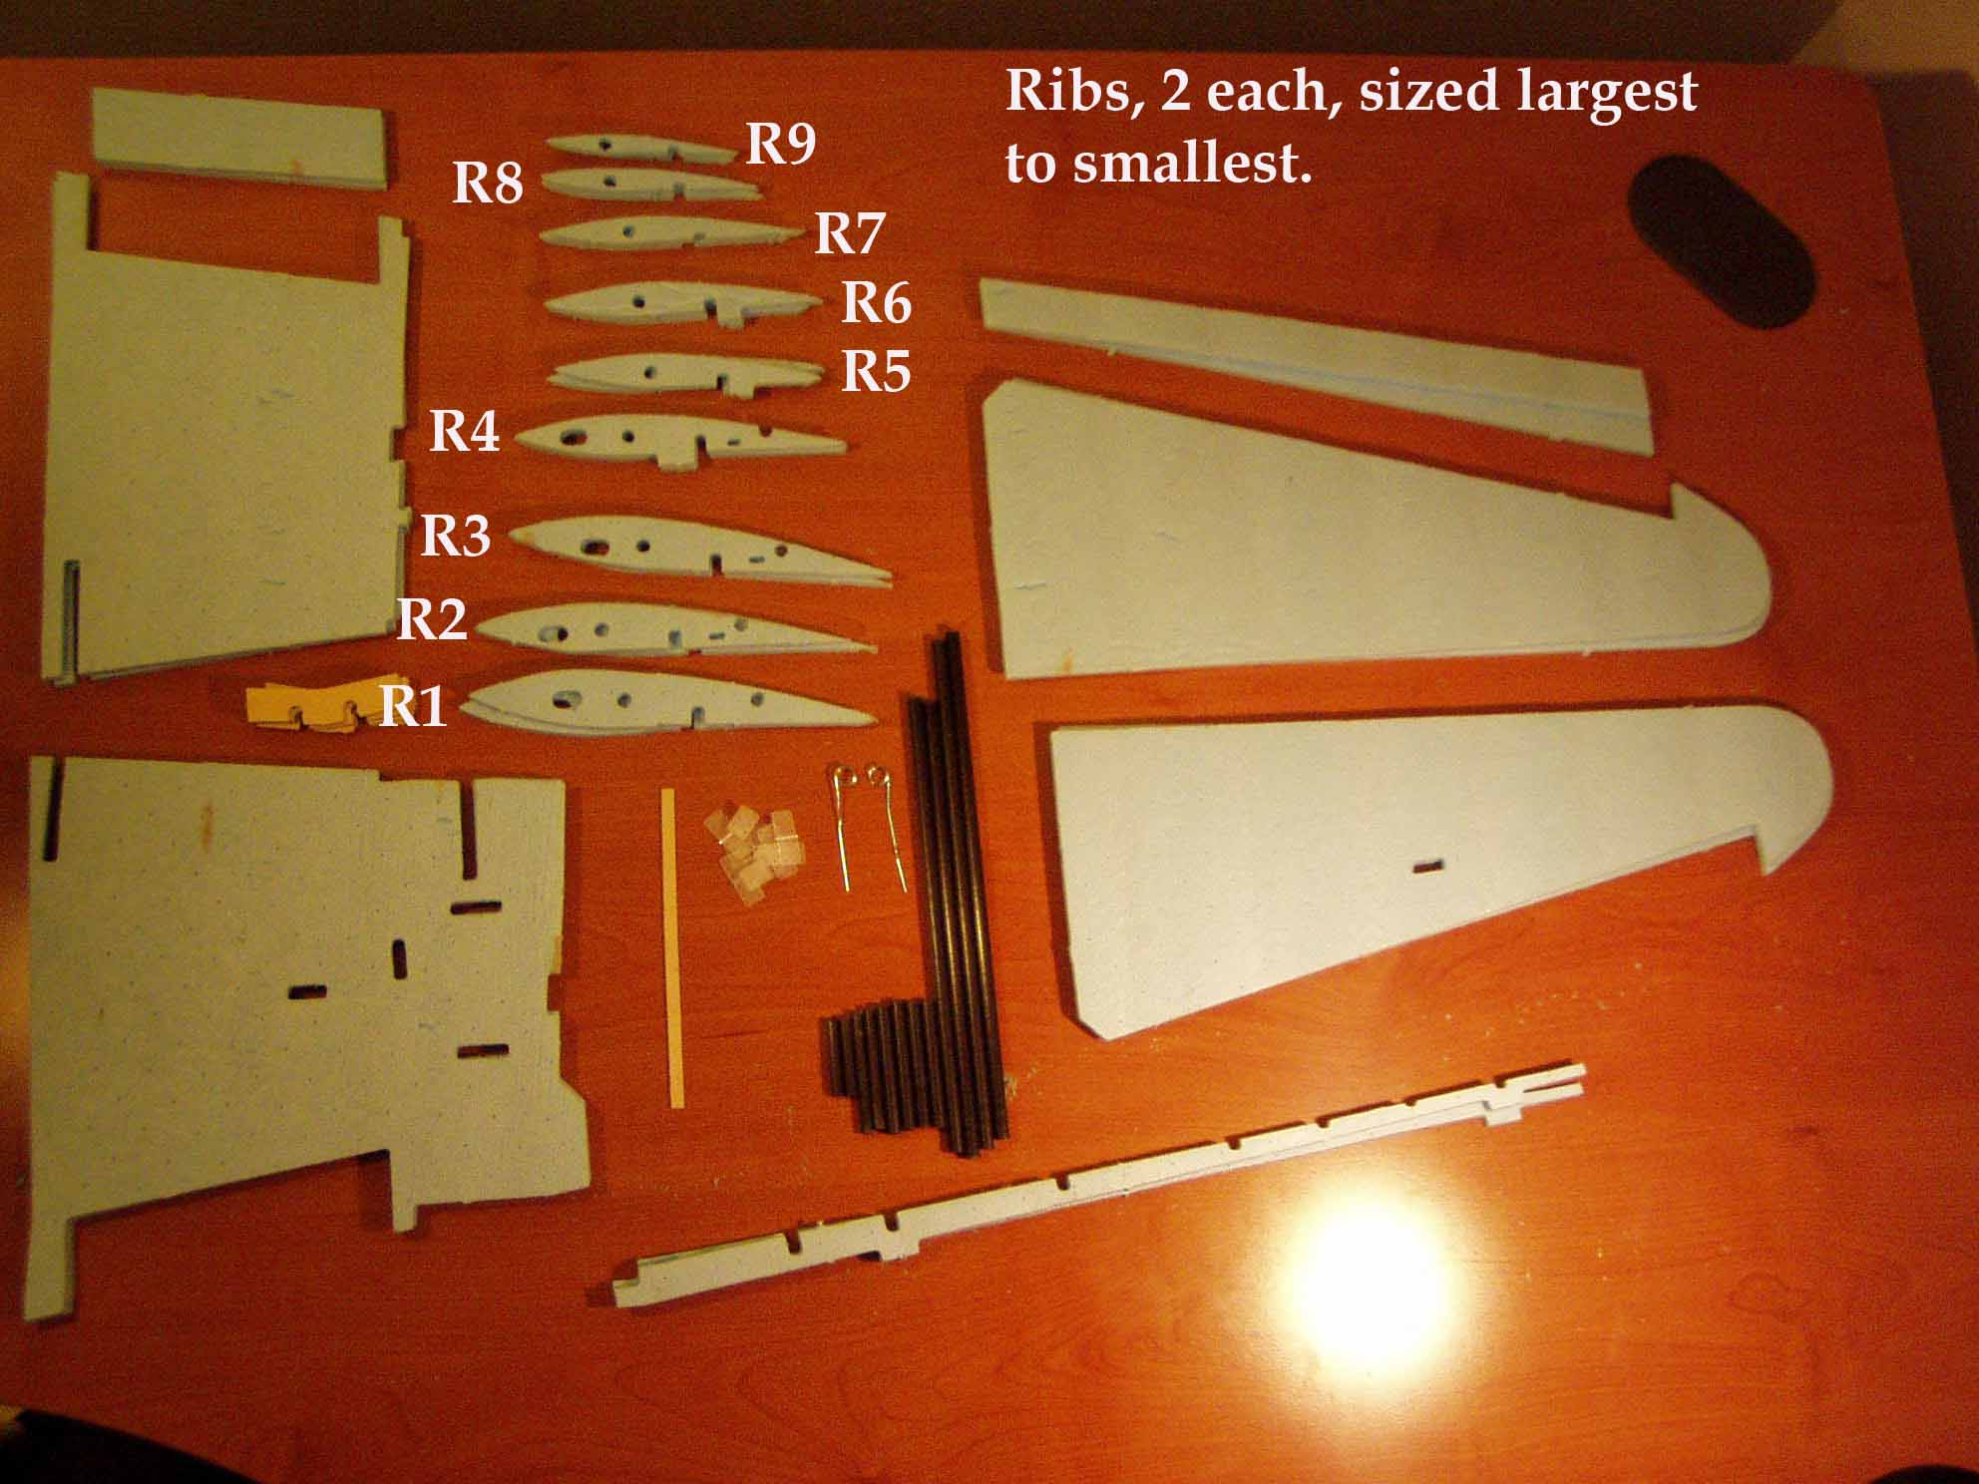
Group the ribs as shown, largest to smallest and make sure you have two of each. Go ahead and number them with a pen so when you are gluing the wing panel together you can tell at a glance that the correct ribs are in the correct spot.
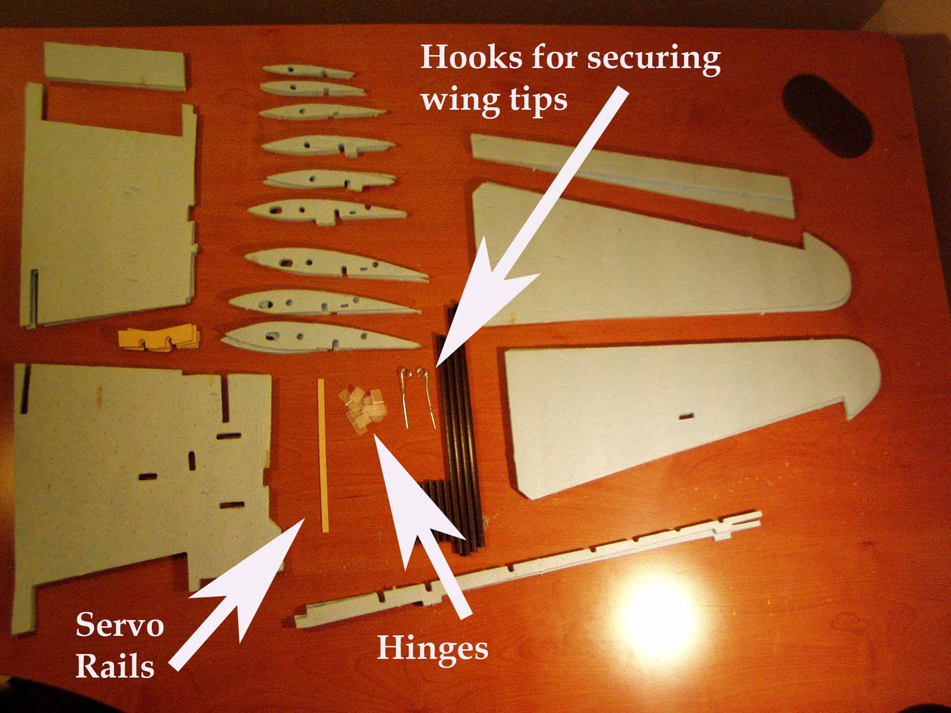
Other miscellaneous parts required for the construction of the wing include the hinges (the type in your kit may differ from those shown), the servo rails and the wing tip hooks.
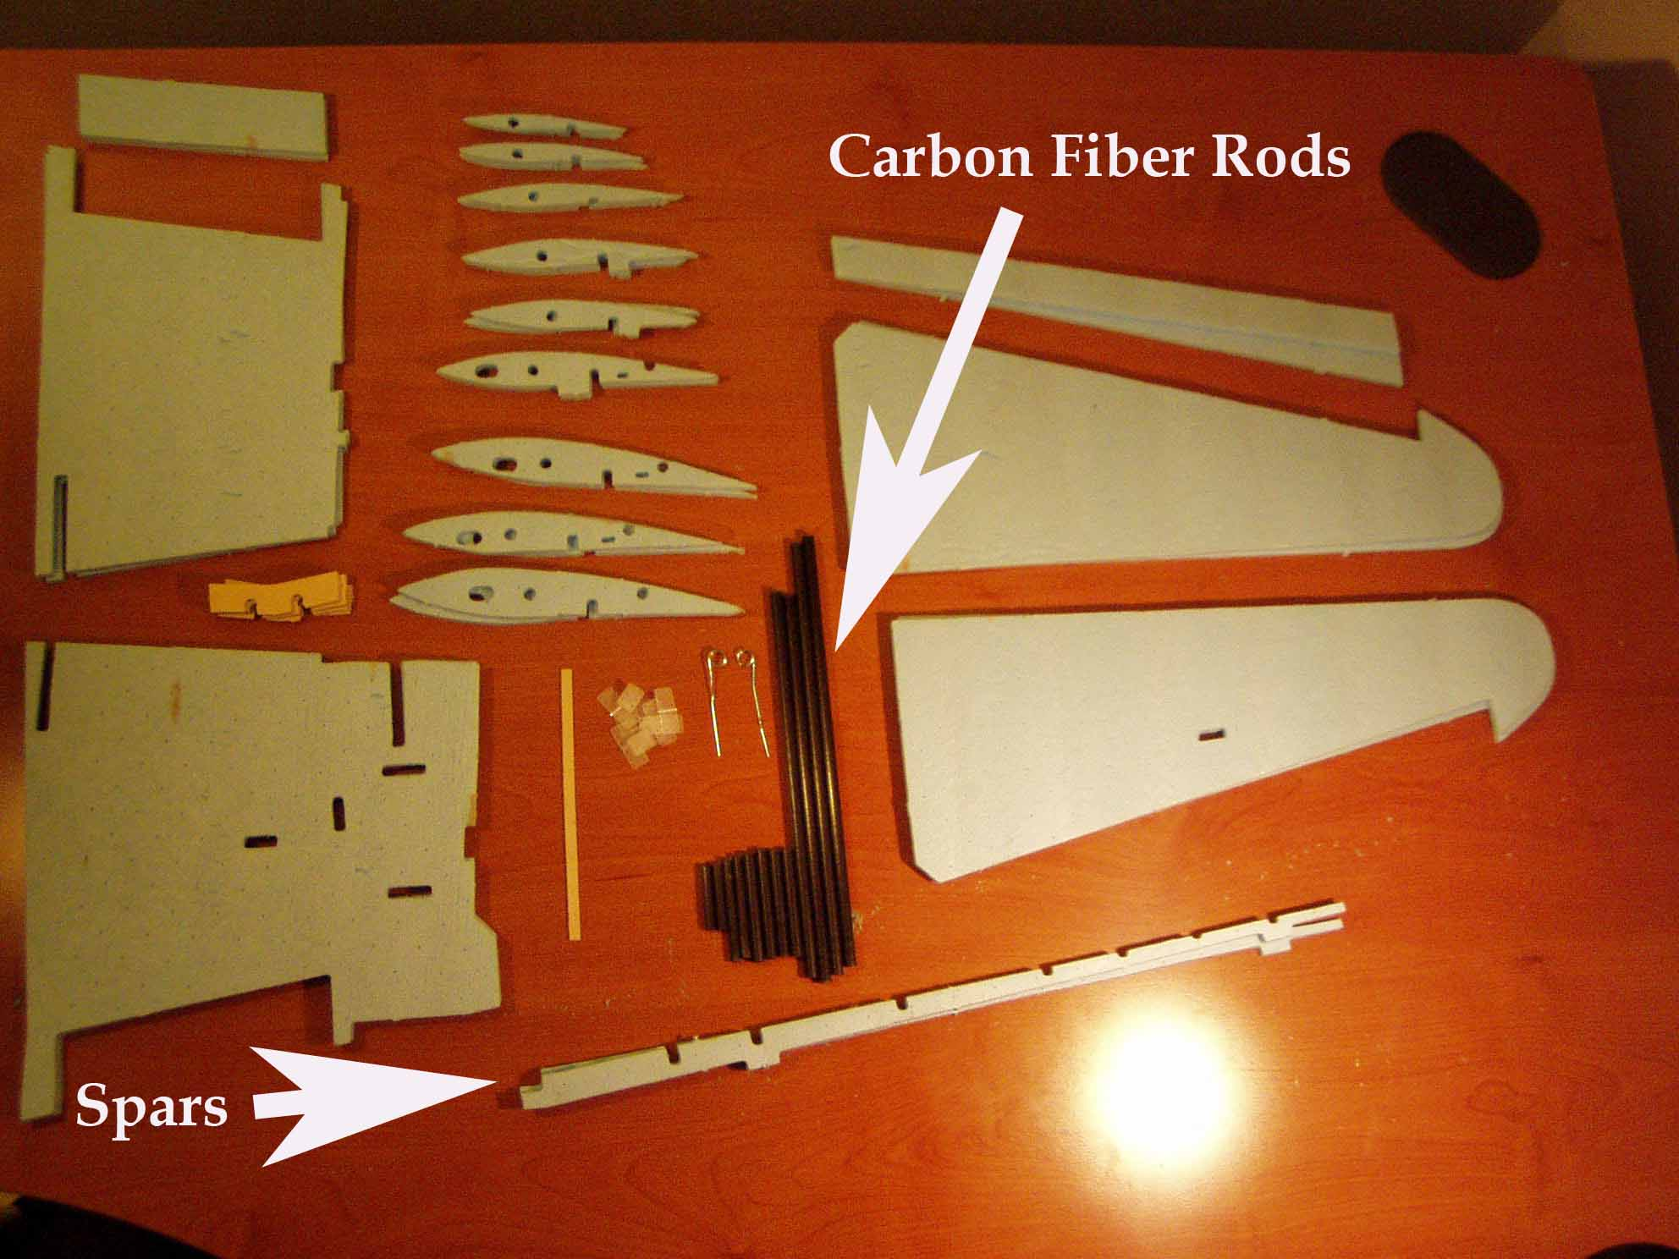
This photo shows the spar and the carbon fiber rods cut and ready for installation. The spar is really only used to properly locate the ribs, the carbon fiber rods provide the real strength in the wing.
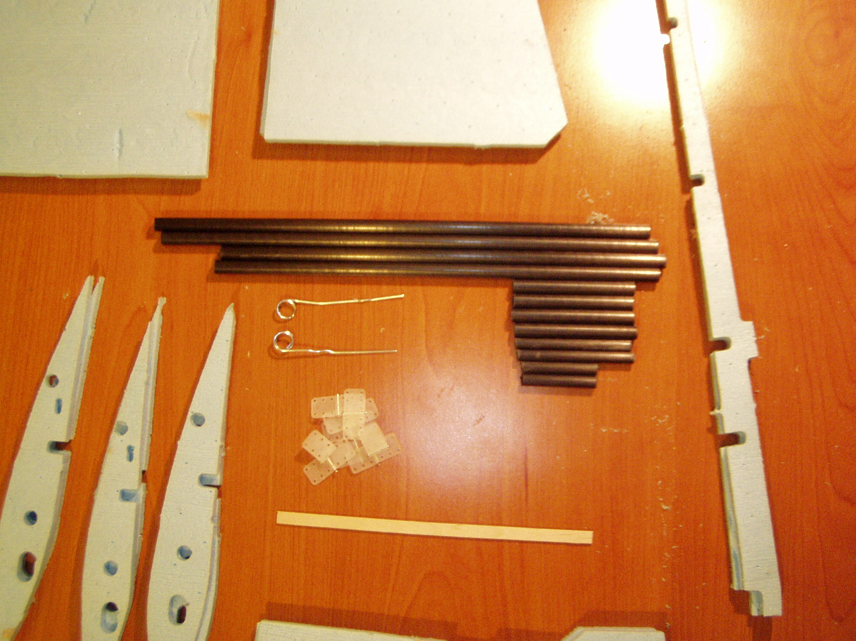The Carbon fiber rods should have been cut to length in an earlier step. The rods used in the wing include the following:
1 main spar wing root
2 main spar wing tip
3secondary spar wing root
4 main spar connector tube
5 rear outer connector tube
6 rear inner connector tube
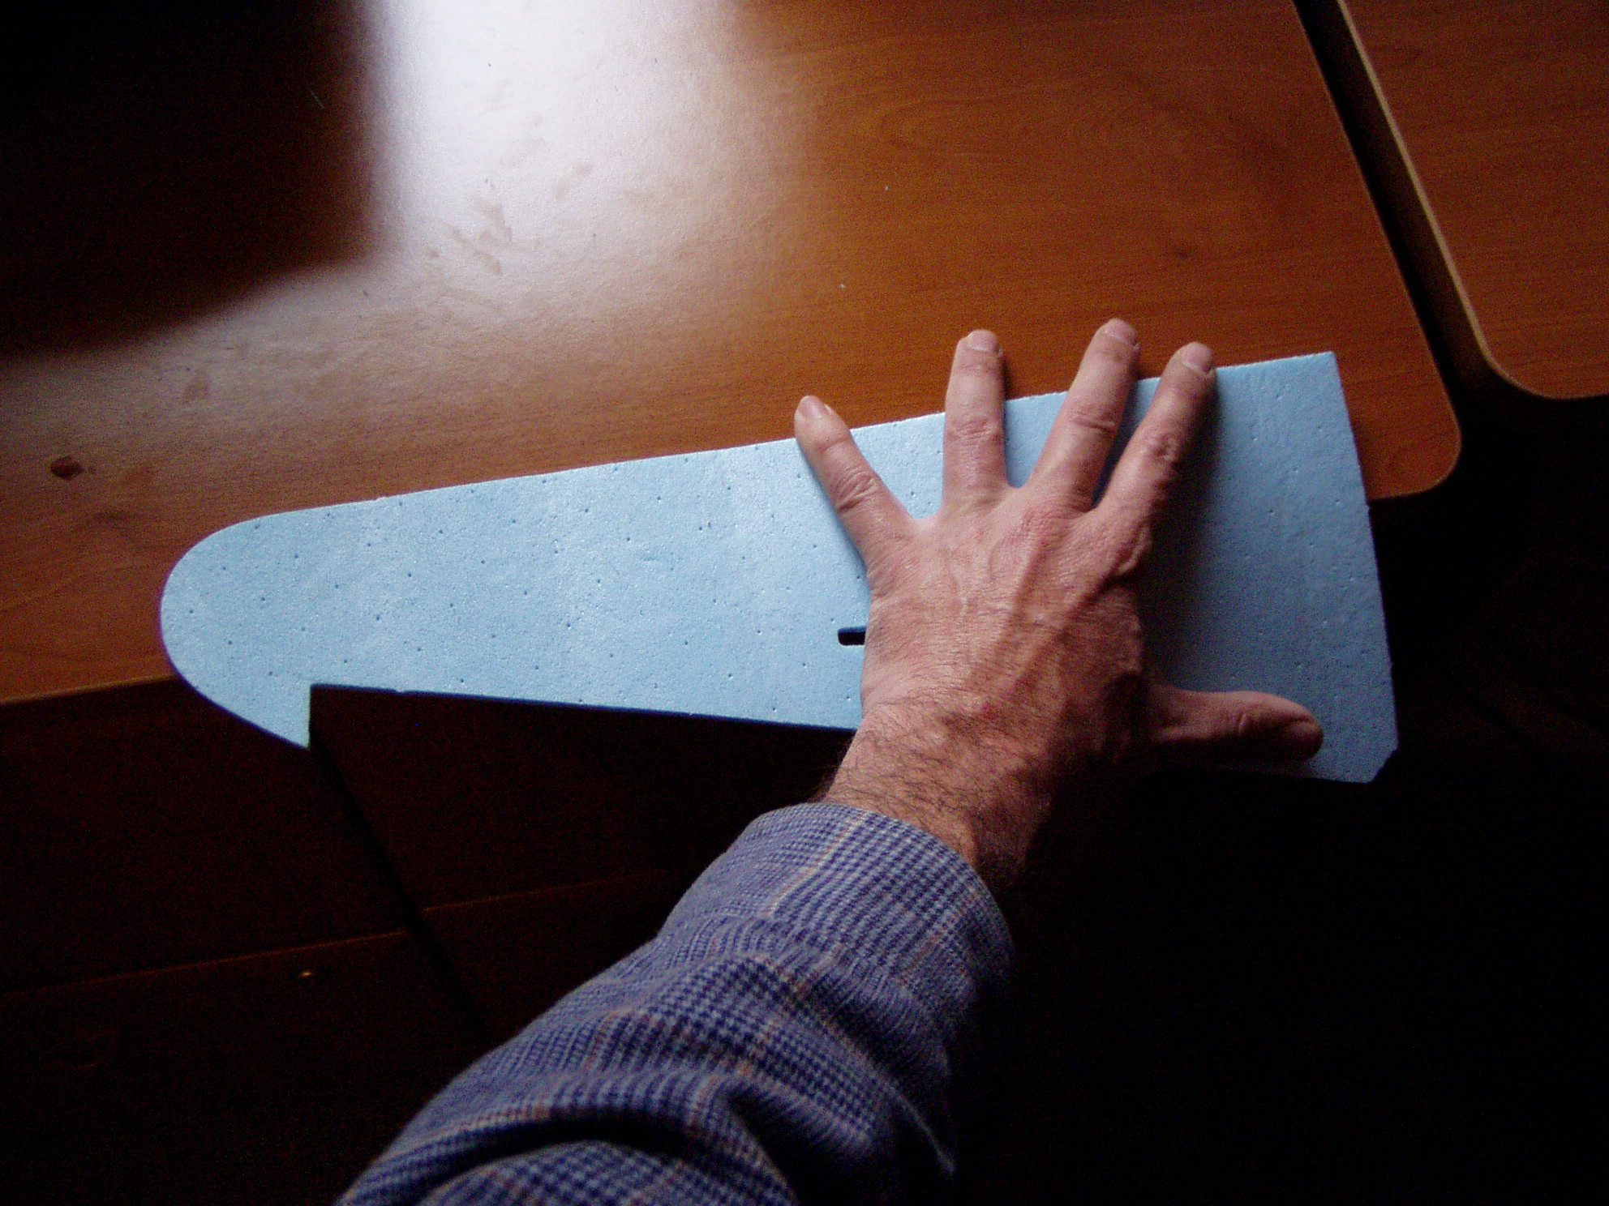

Gently Roll the leading edge of the bottom wing panel over a sharp table edge.
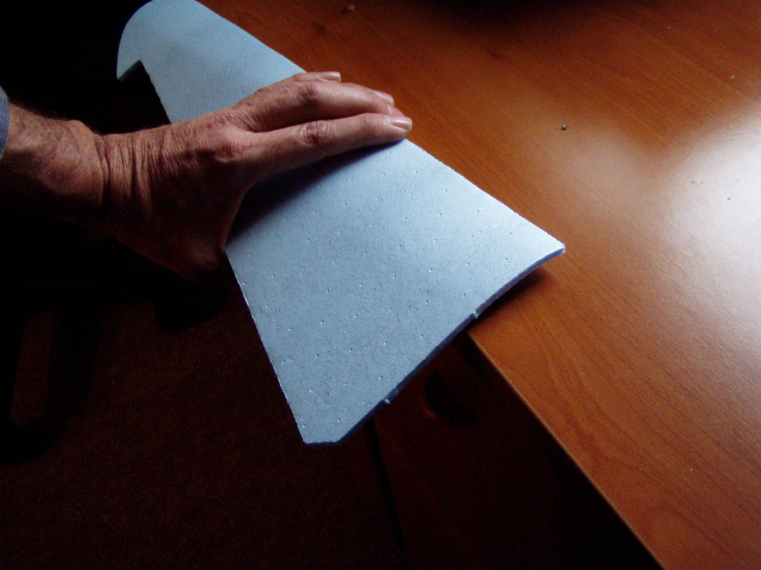
Using two hands with your fingers spread out and a slight pressure as the foam is rolled over the edge provides the slight curvature required for the airfoil.
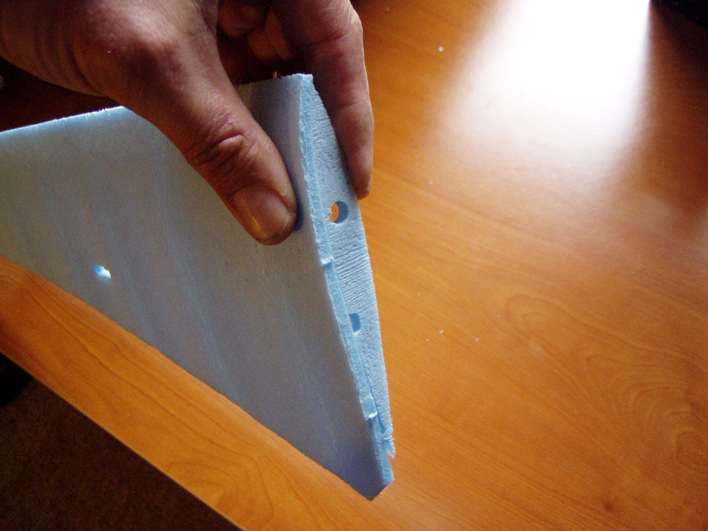
Use a rib to get a sense for the amount of curve, it is actually very slight.
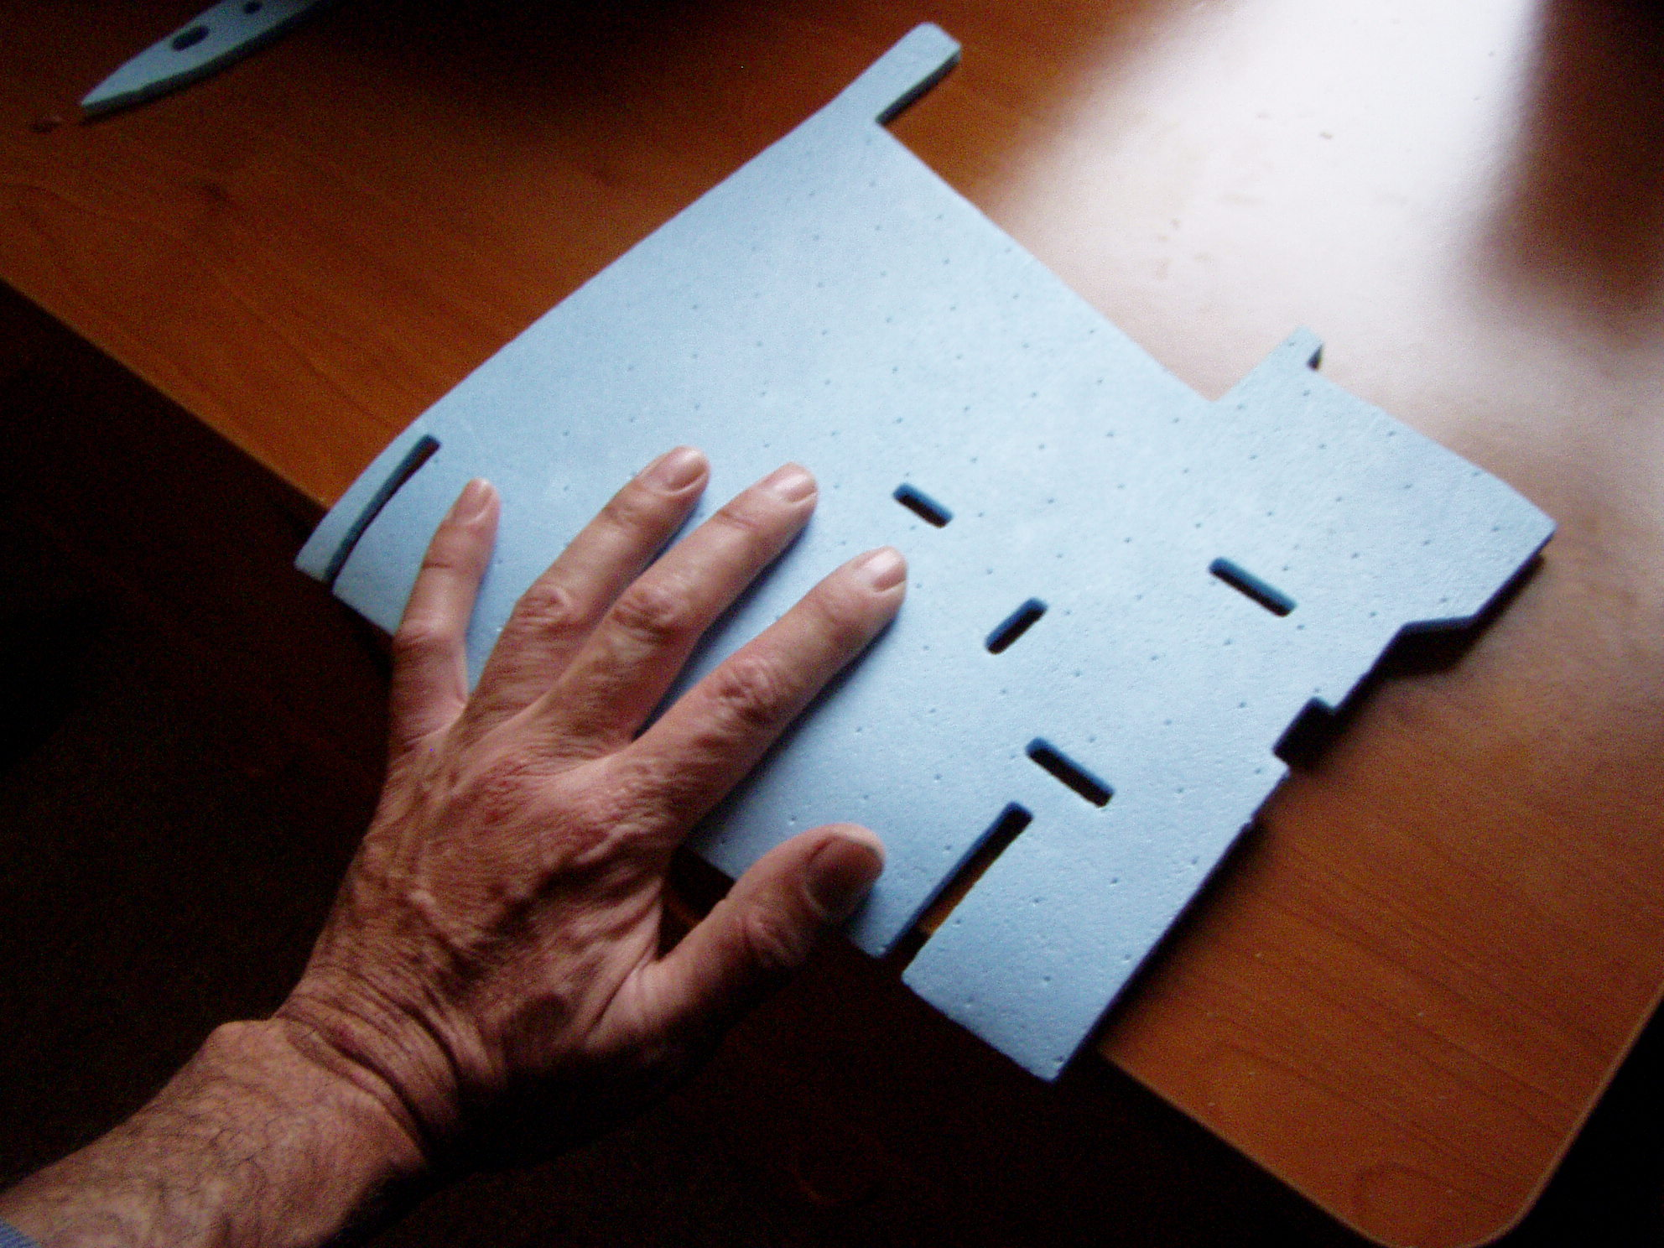
Likewise roll the wing bottom inboard panel to achieve the airfoil shape.
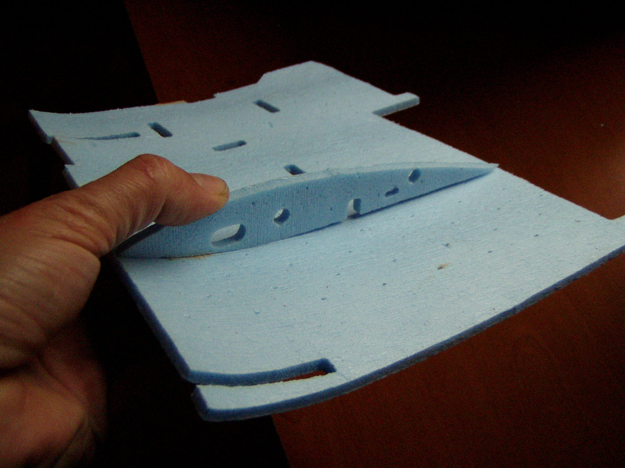
Again use a rib as a gauge for the proper curvature. It is not too critical because the true wing shape will be determined by the ribs pinned to the panel during the gluing step.

Also roll the wing panel tops and set aside.
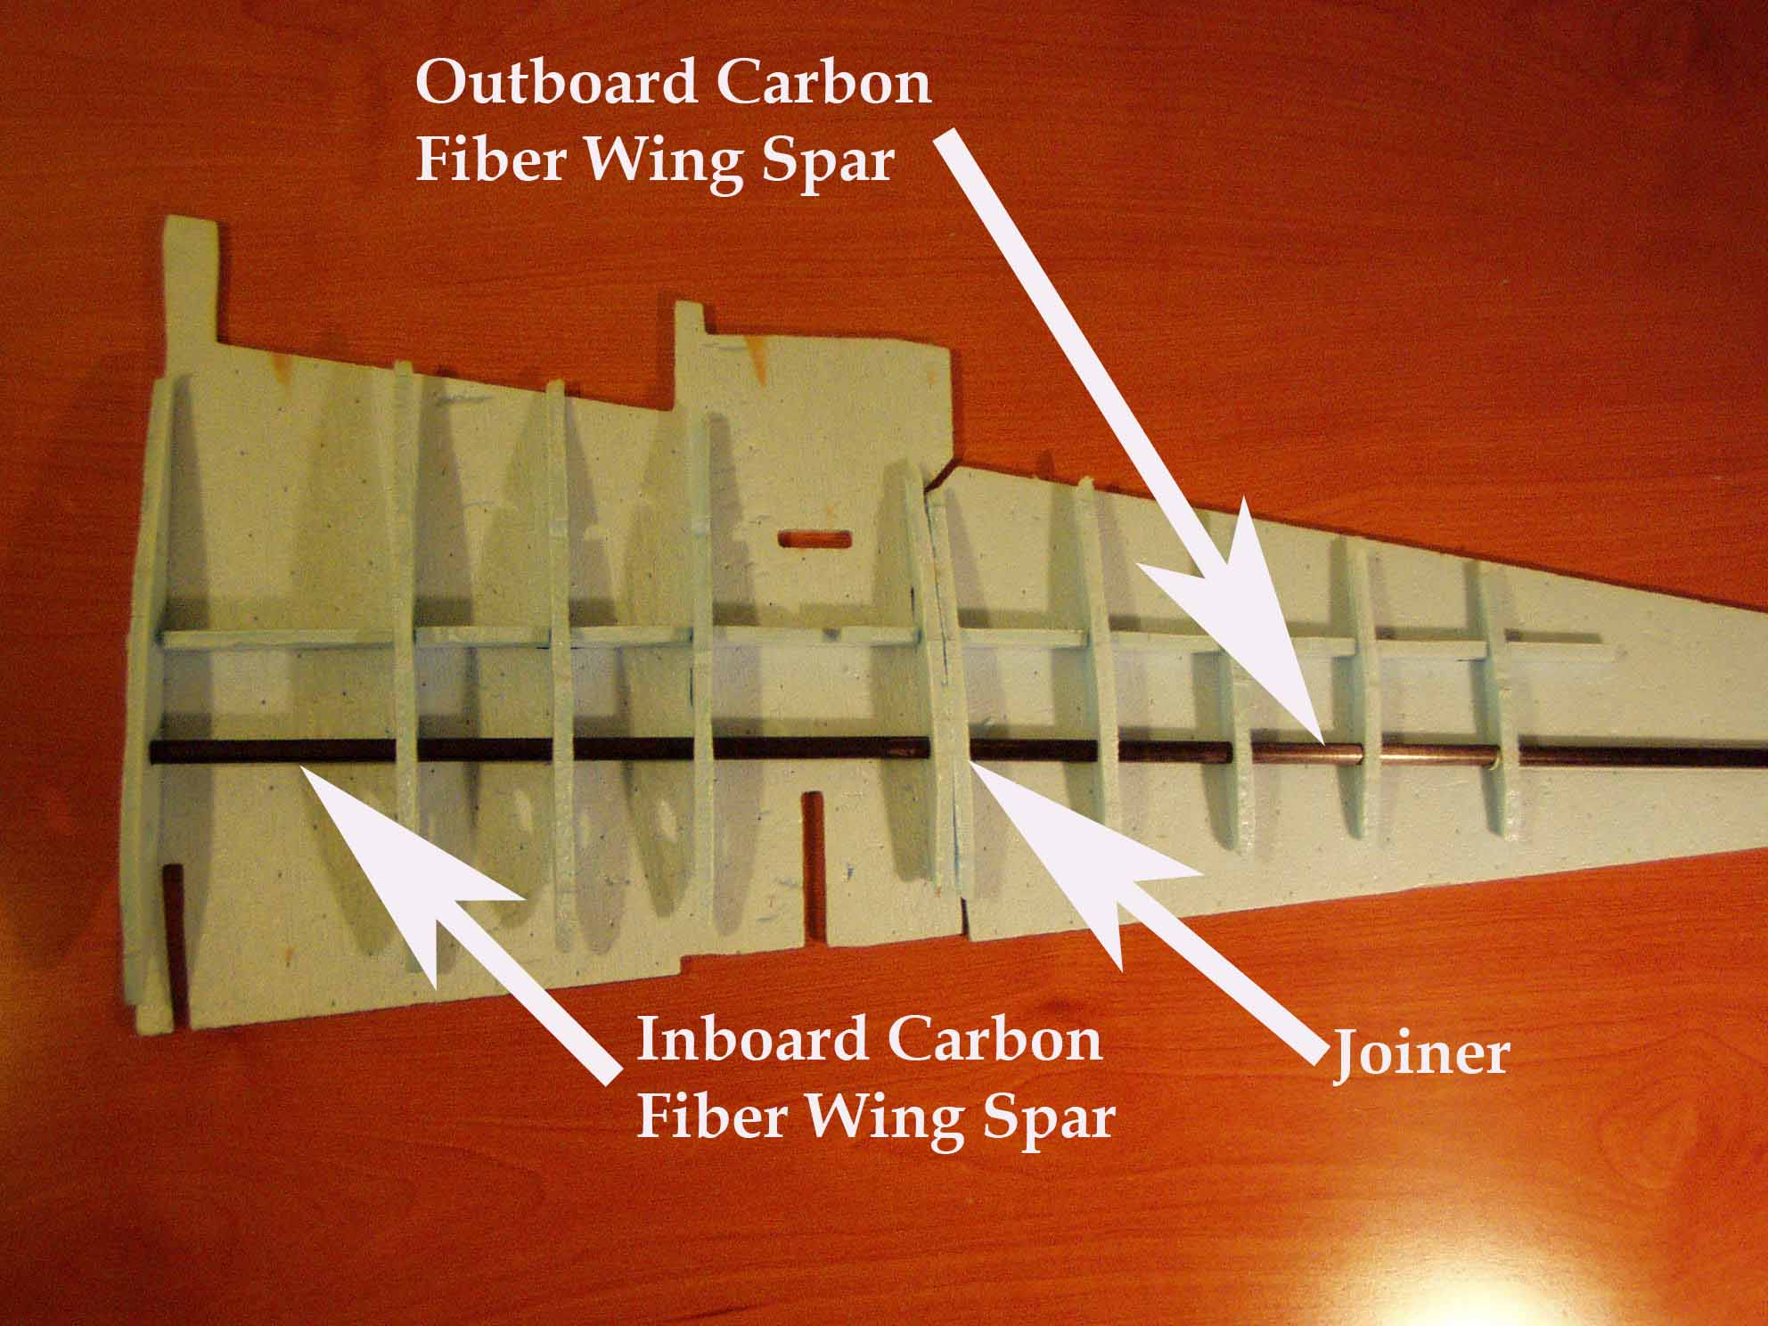
Position the bottom wing panels next to one another as shown. Pin to a cardboard sheet with straight pins. Use wax paper between the foam and the cardboard so the panels don’t stick when glued. Snap the foam spar into the slots as shown in the above photo.
Temporarily join the inboard and outboard spars with the carbon fiber rod joiner. Do not glue the carbon fiber at this stage.
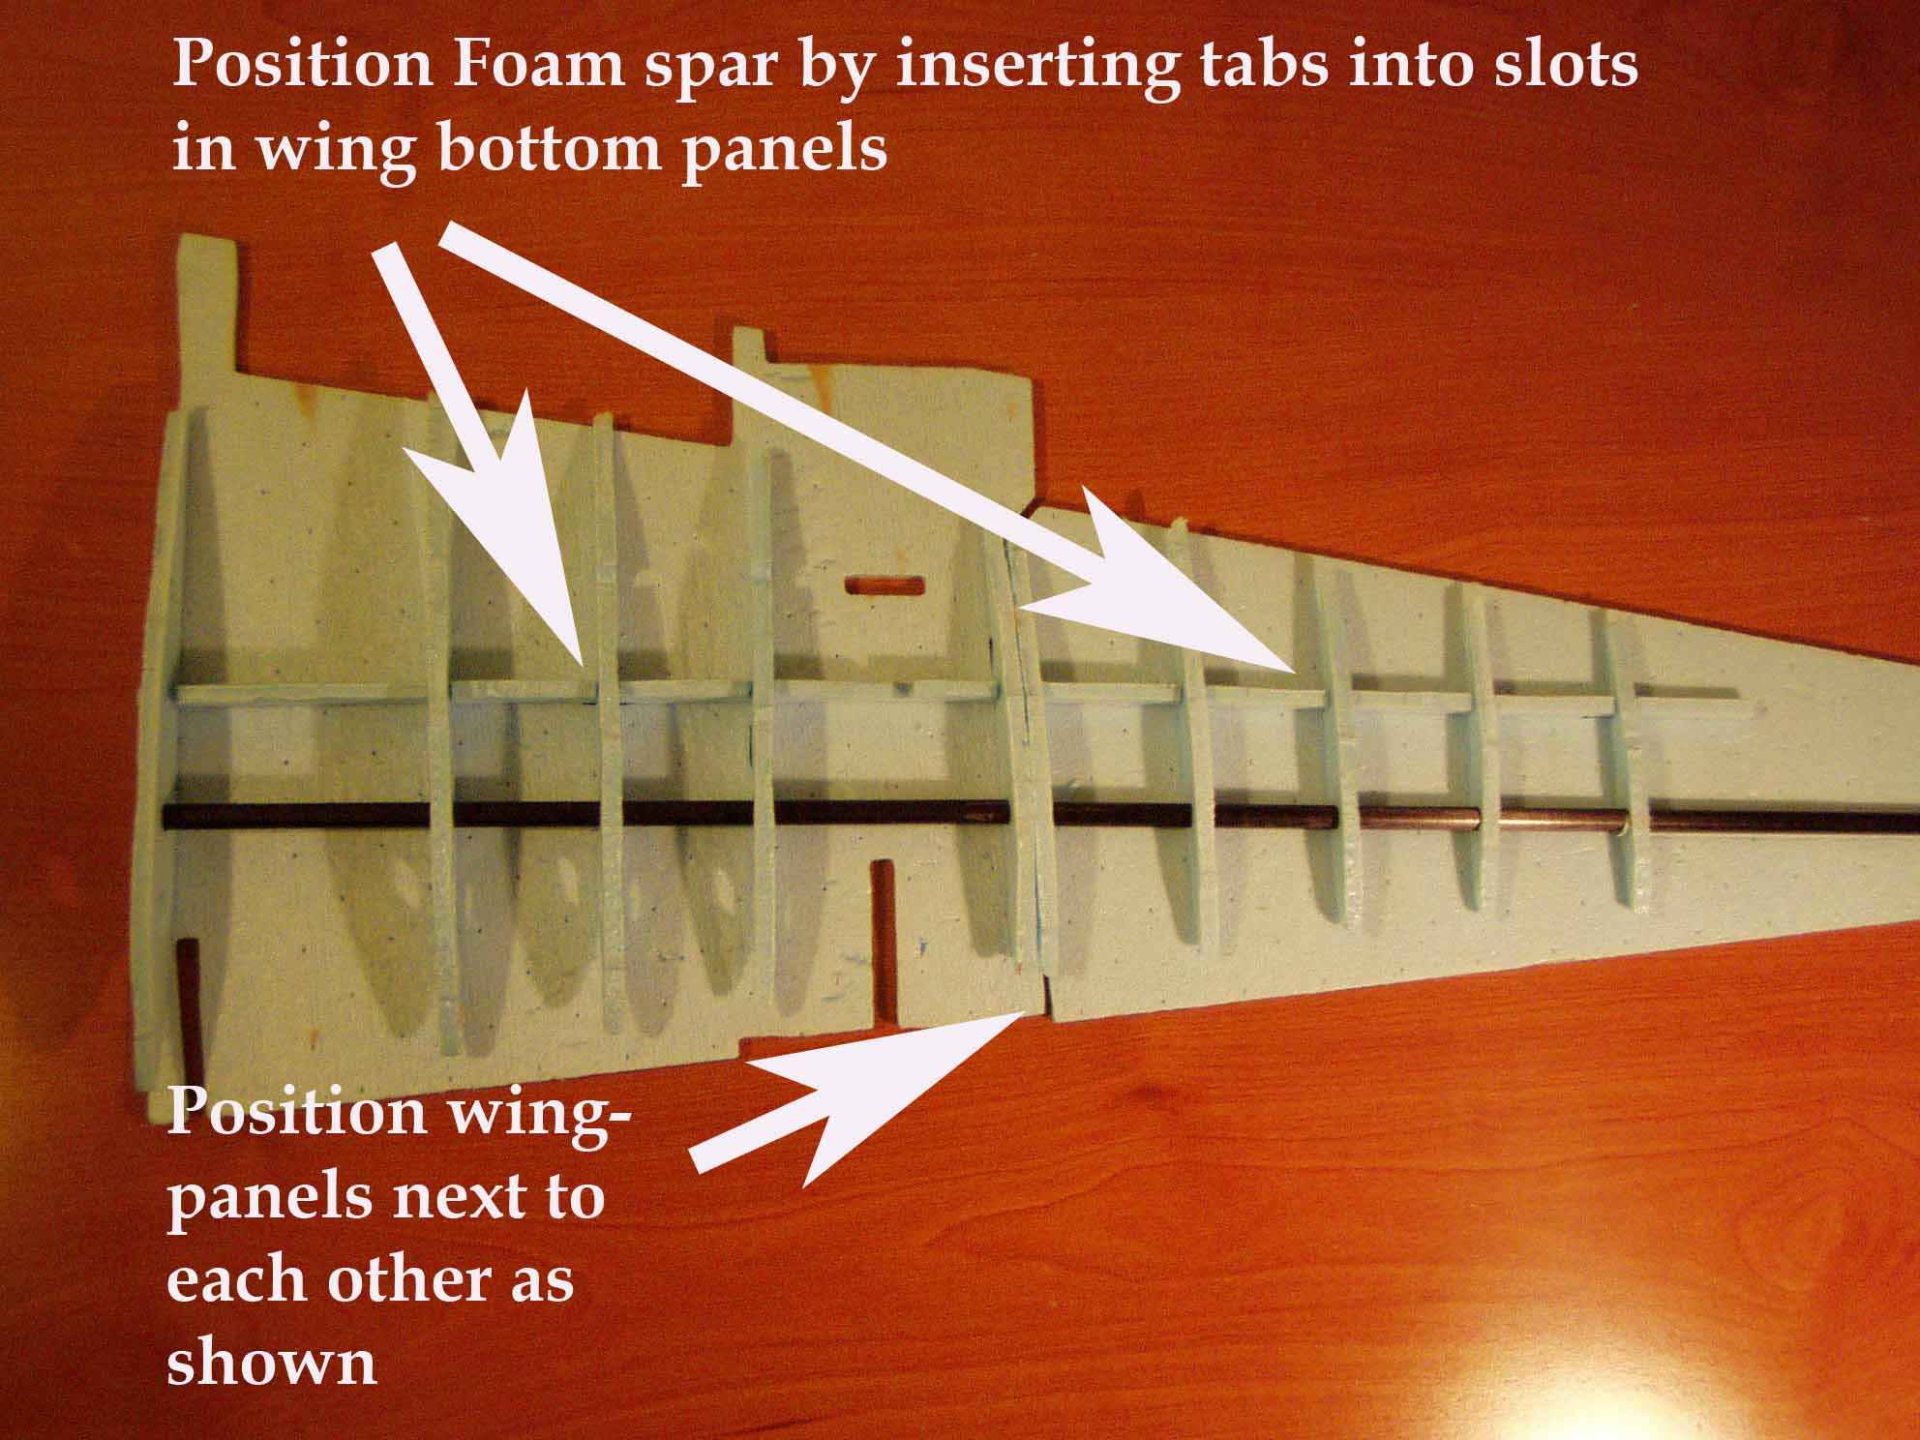
Slide all of the ribs onto the carbon fiber spar shaft in order. Then slide them into proper position to align with the foam spar.
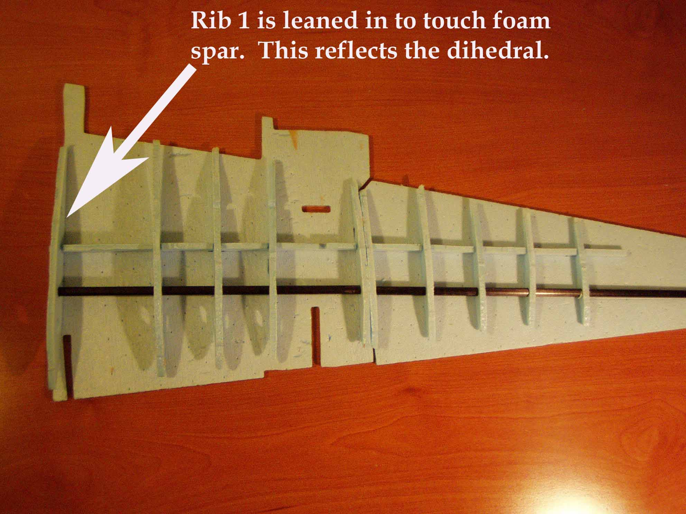
Test fit all of the ribs in position. Slide the spar shafts through the holes in the ribs and make all of he ribs parallel with one another. Adjust the position of the ribs so they are all parallel and running front to back straight.
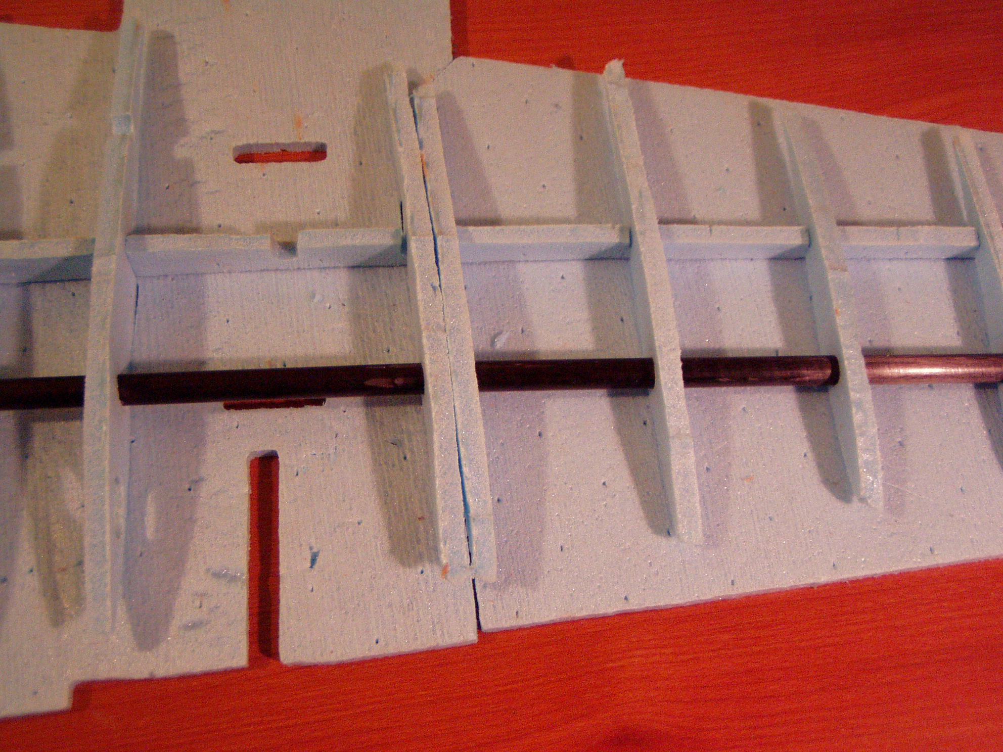
Close up of the joint between the inboard and outboard wing sections.

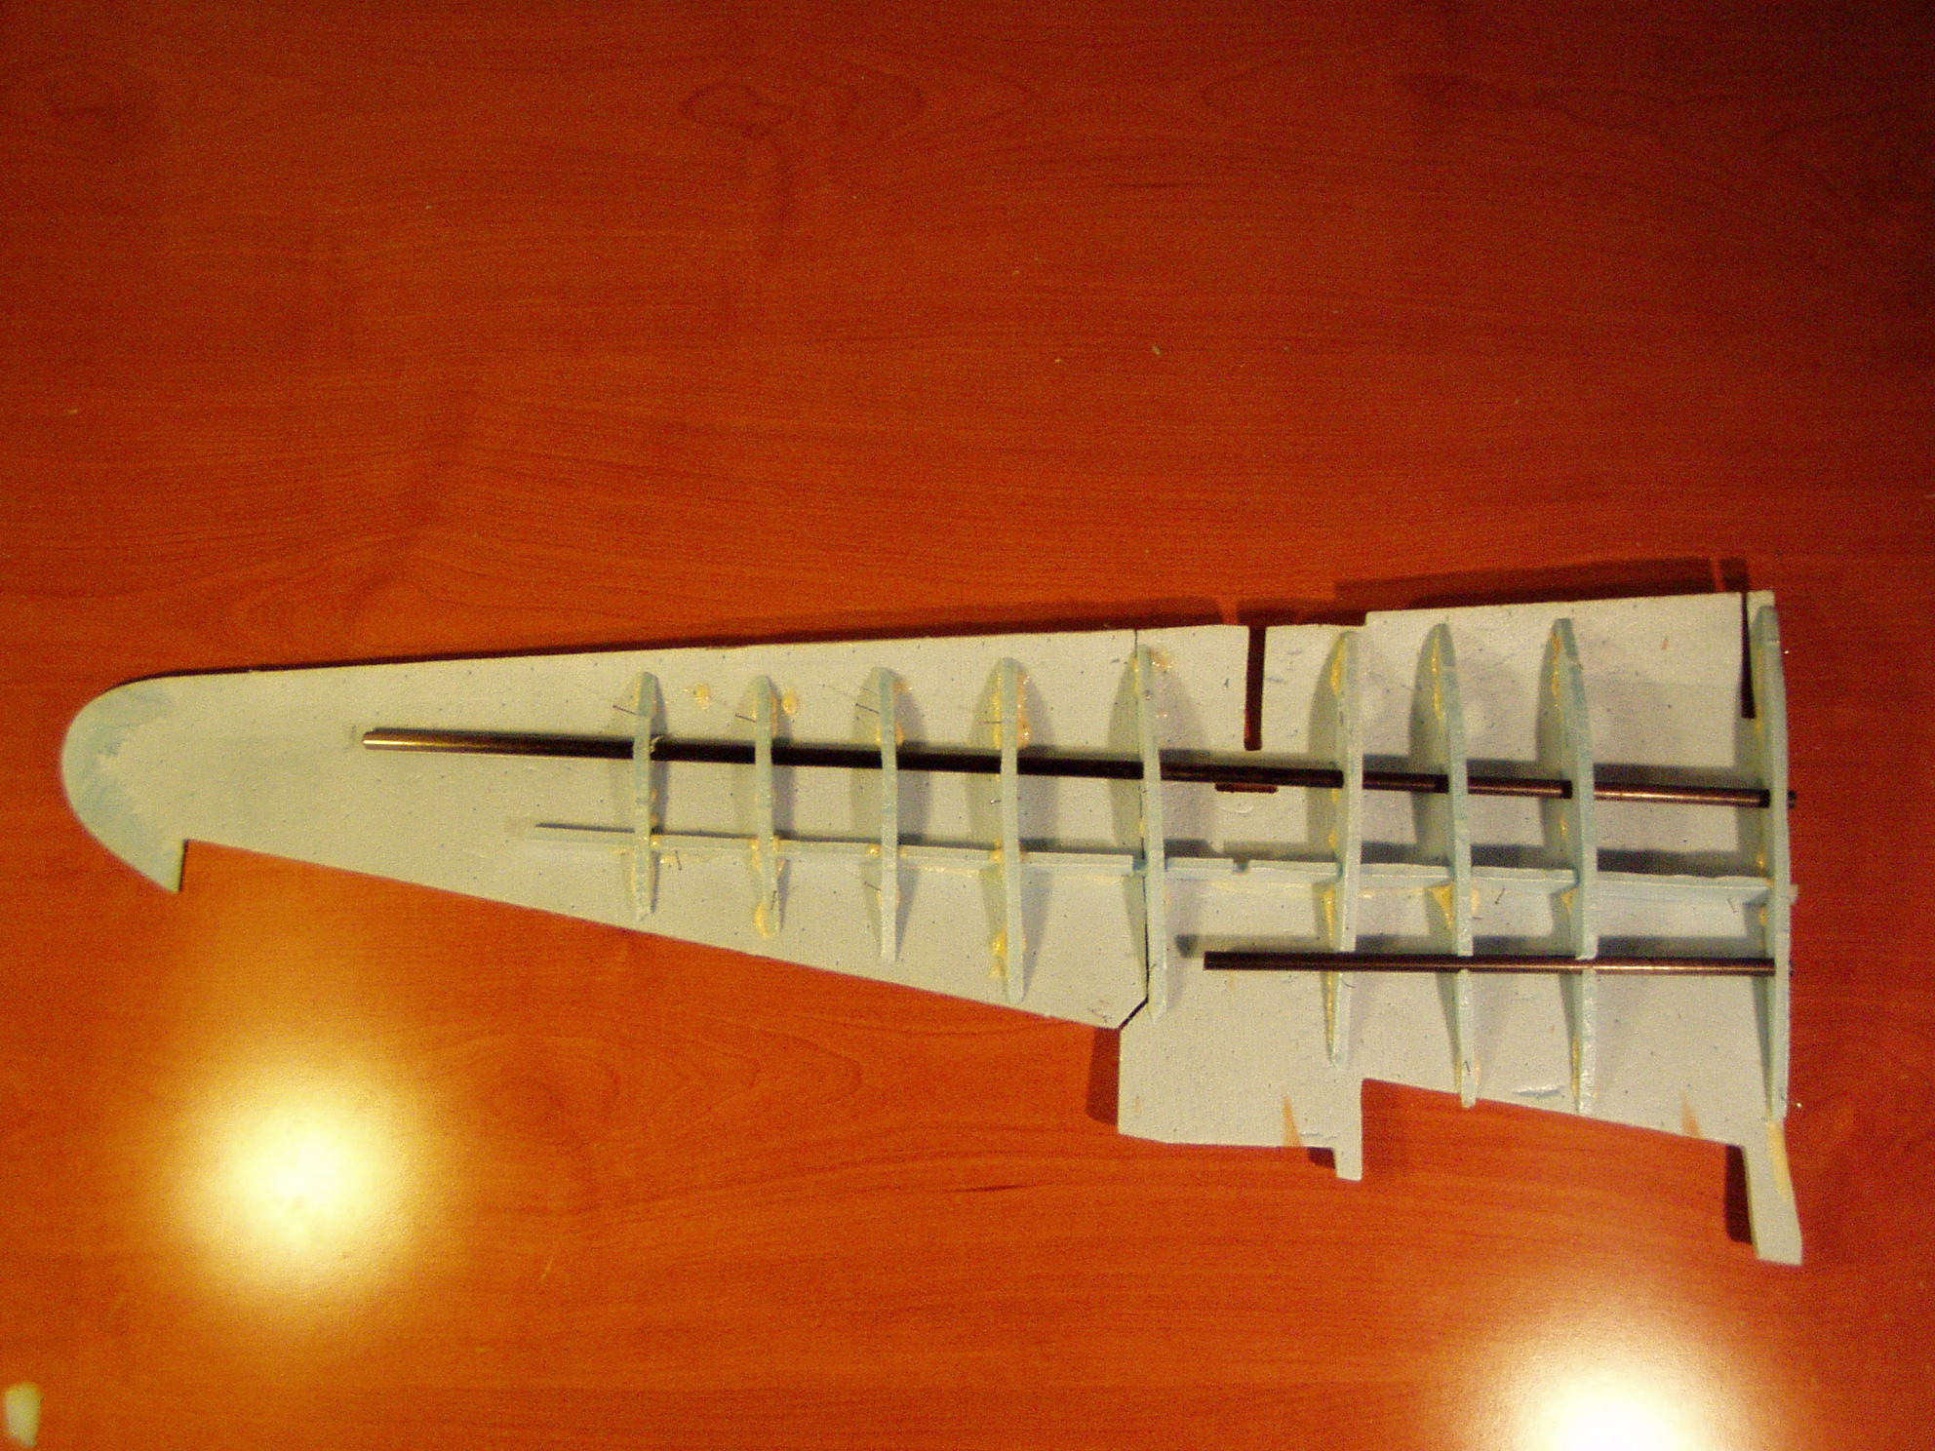
When you are happy with the fit, glue all of the foam pieces together. Do not glue the carbon fiber rods in at this point. Do nopt glue the inner and outer wing panels together as these will separate for easy transport.

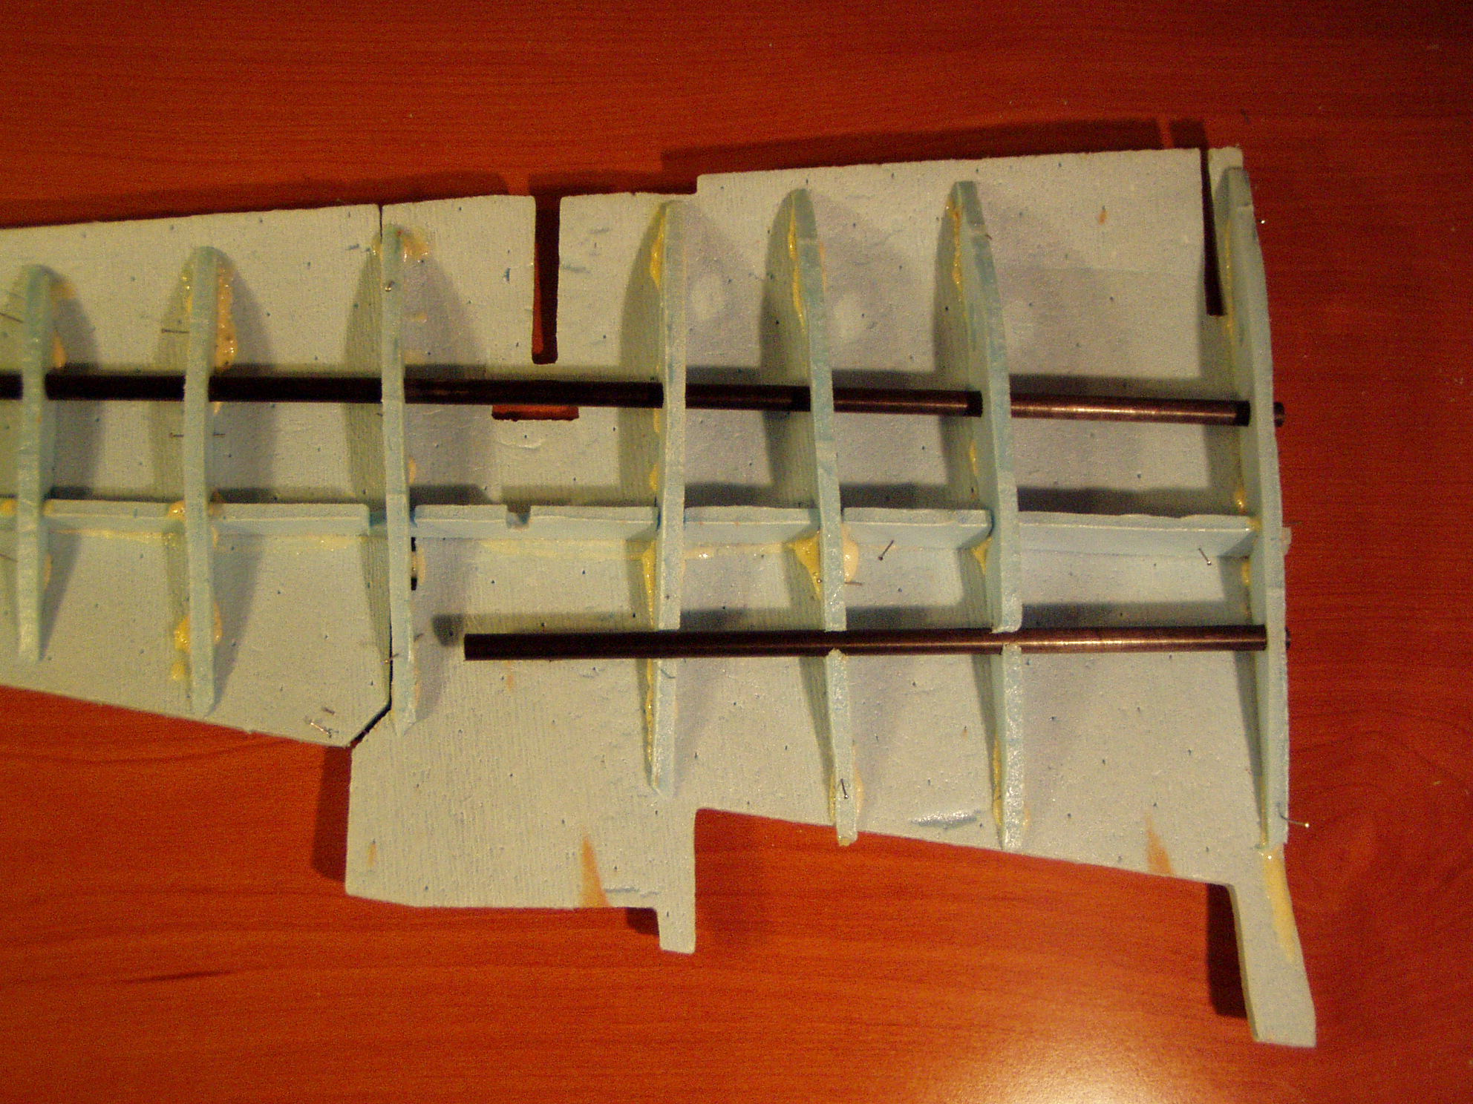
Close up of the inboard wing section, The secondary wing shaft is used to align the ribs. Again do not glue in the carbon fiber shafts at this point. When the glue has dried lift the panels off the workbench.

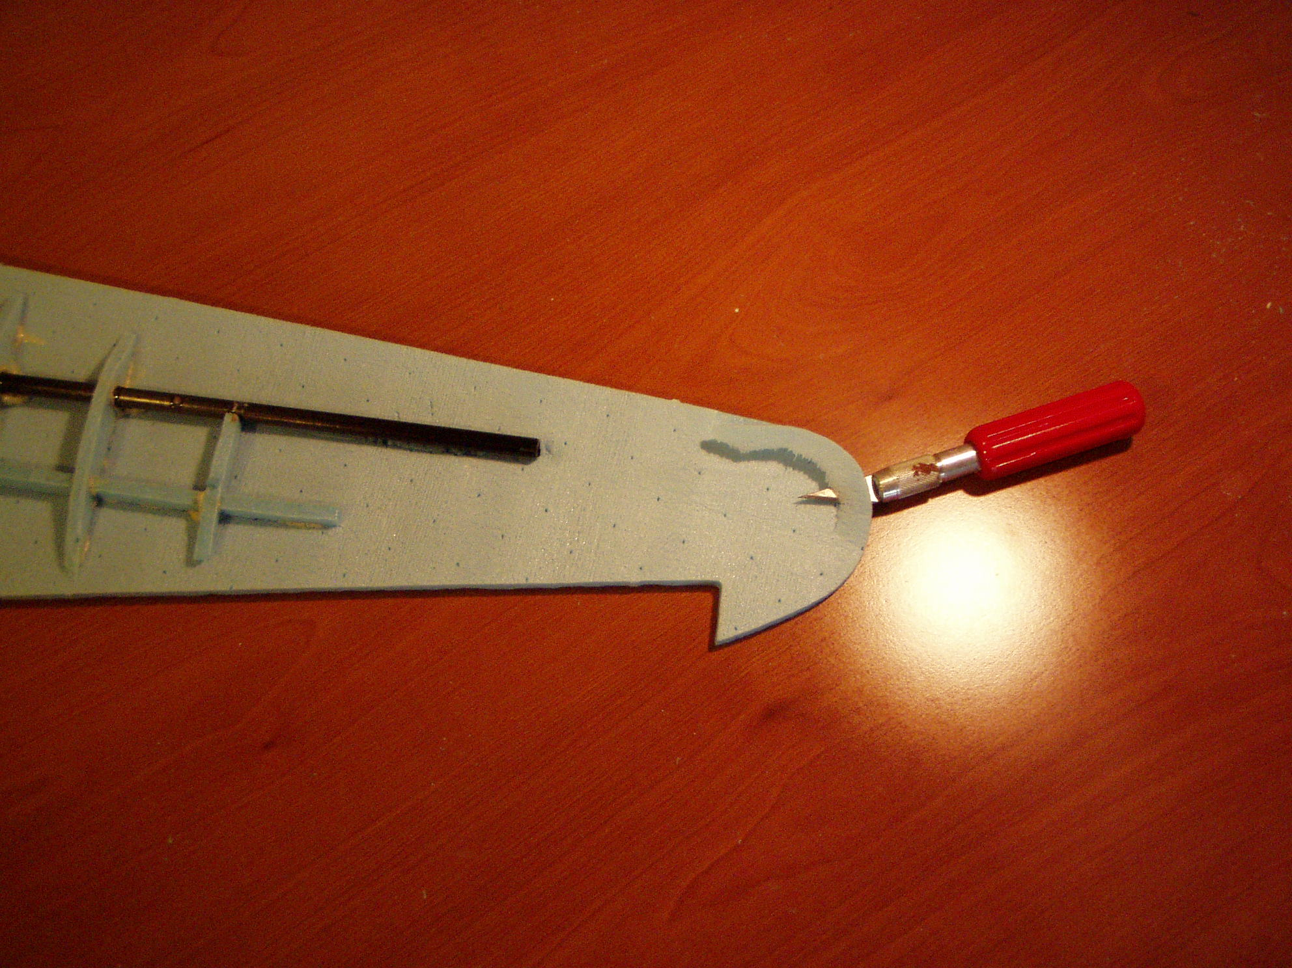
Use an exacto knifet o remove a small amount of foam from the inside wing tip. This will provide the thinned wing tip when the top and bottom panels are glued together.
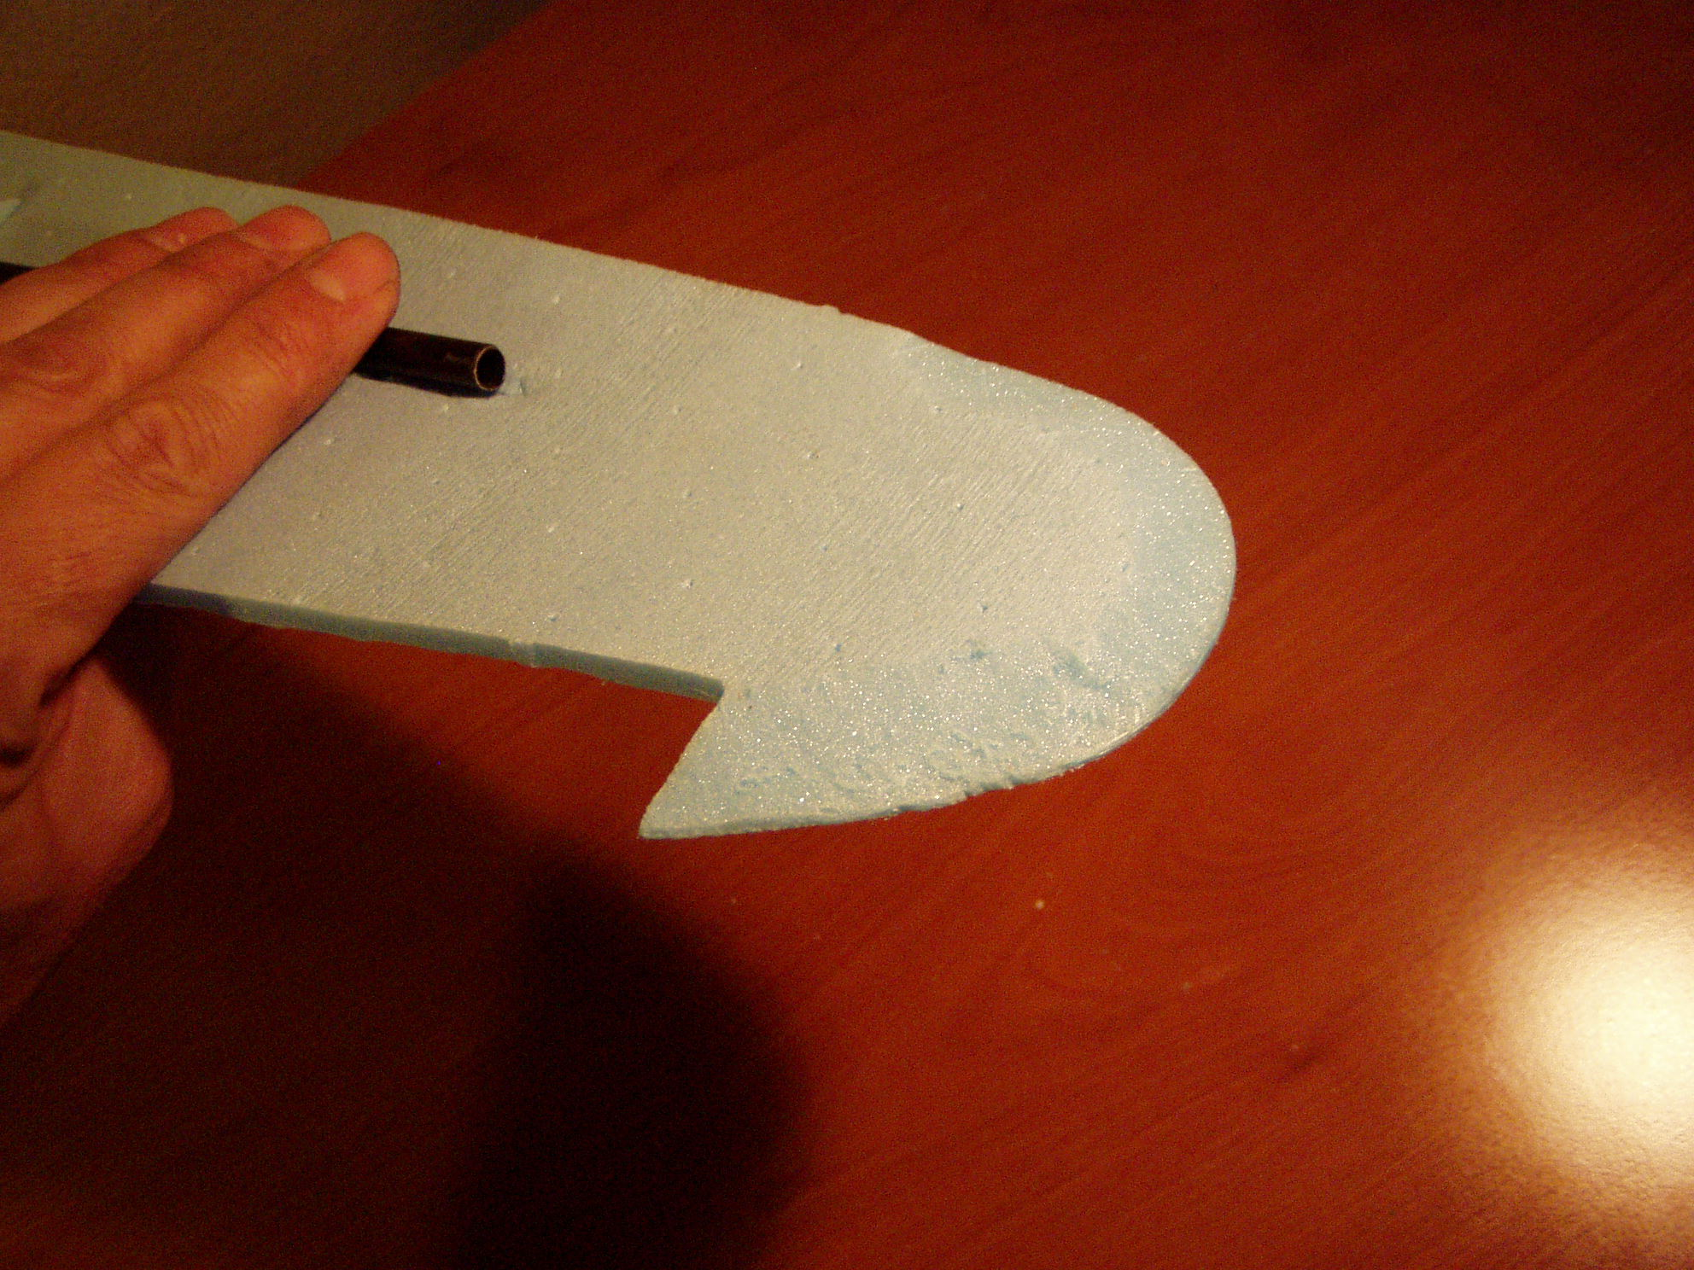
Close up of trimmed wing tip.
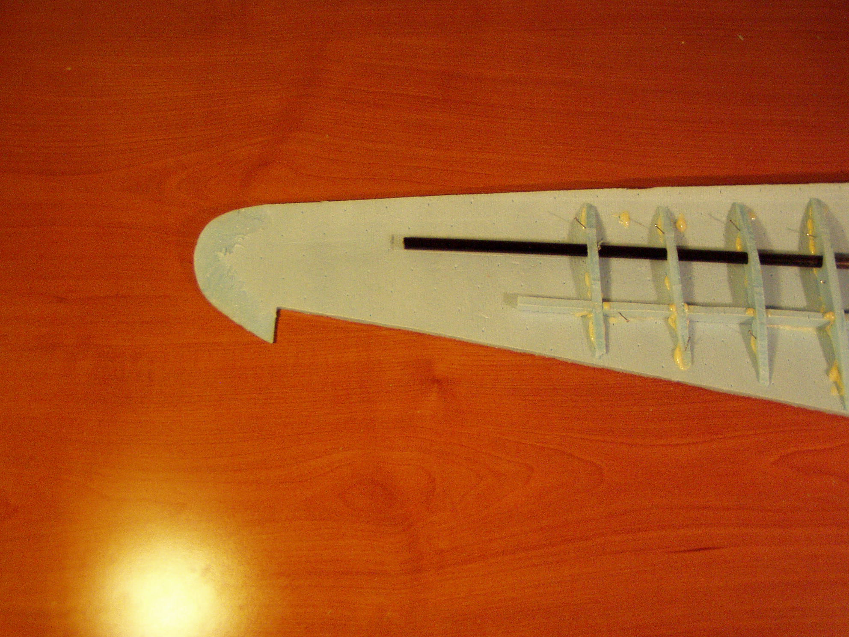
Clolse up of the wing tip. Notice the thinned wing tip.

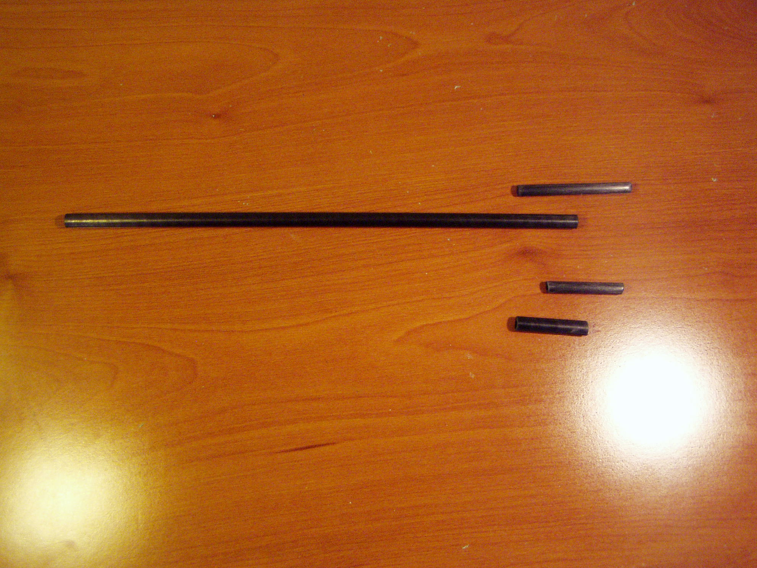
Above is shown the inboard main spar and the inner shaft joiner as well as the secondary joiner tubes.
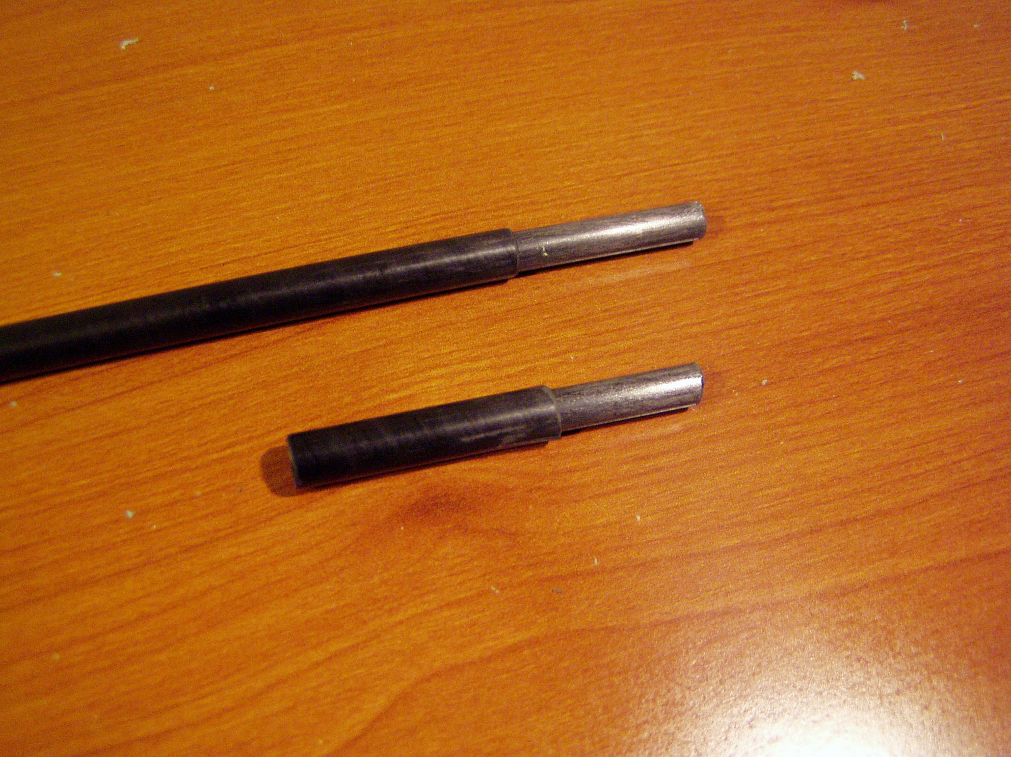
glue the inner tubes in place being careful not to get glue on the sliding surface of the inner tube. Refer to the Getting Started Guide for a more detailed description of preparing and identifying the carbon shafts.
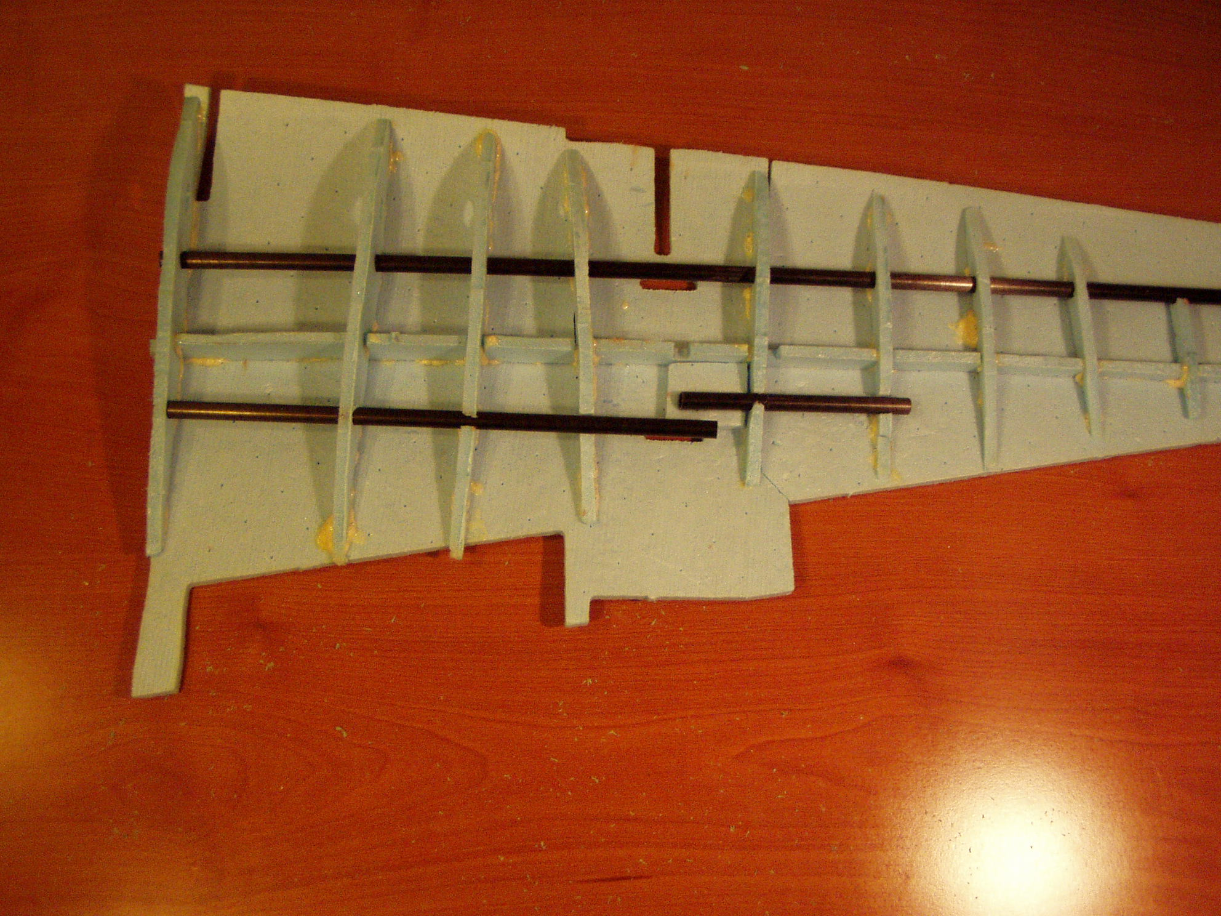
Position all of the rods in place making sure the joiner shafts are co planer so the wing will slide apart smoothly.
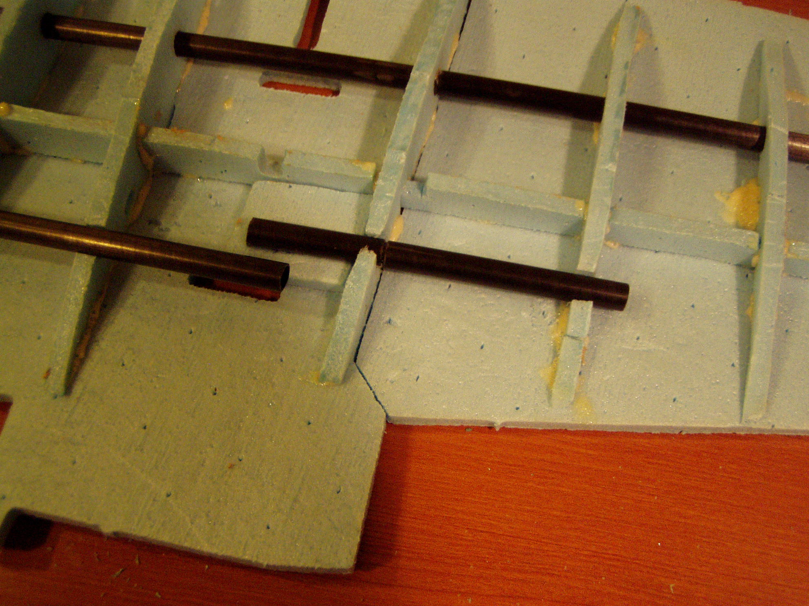
A small piece of scrap is used to space the rear joiner into position as shown.
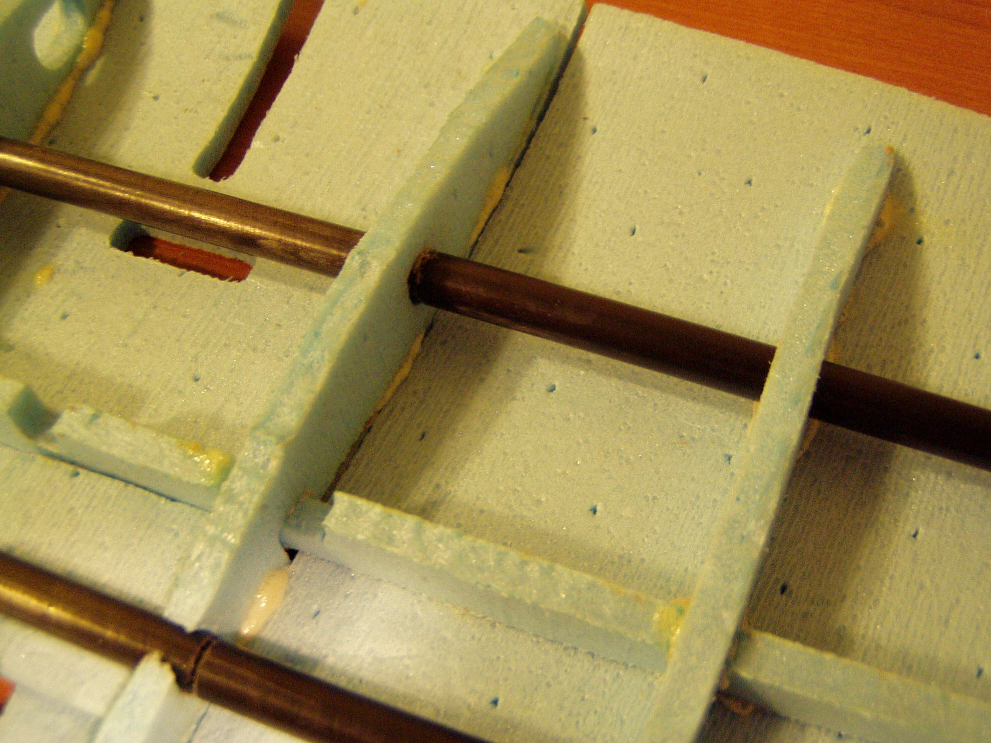

Close up of properly position shafts. Once you are happy with the location of the joiner shafts glue them to the wing tip and the wing root. It goes without saying, be sparing with the glue, you do not want to glue the two wing halves together. I like to use a small amount of glue to secure the position of the tubes. Then once the glue is dried, separate the two wing panels and securely glue the rear joiner shaft into position. The main shaft should only be tacked into position. In a couple of steps we will add washout to the wing tip and securely glue the main tube shaft spar.

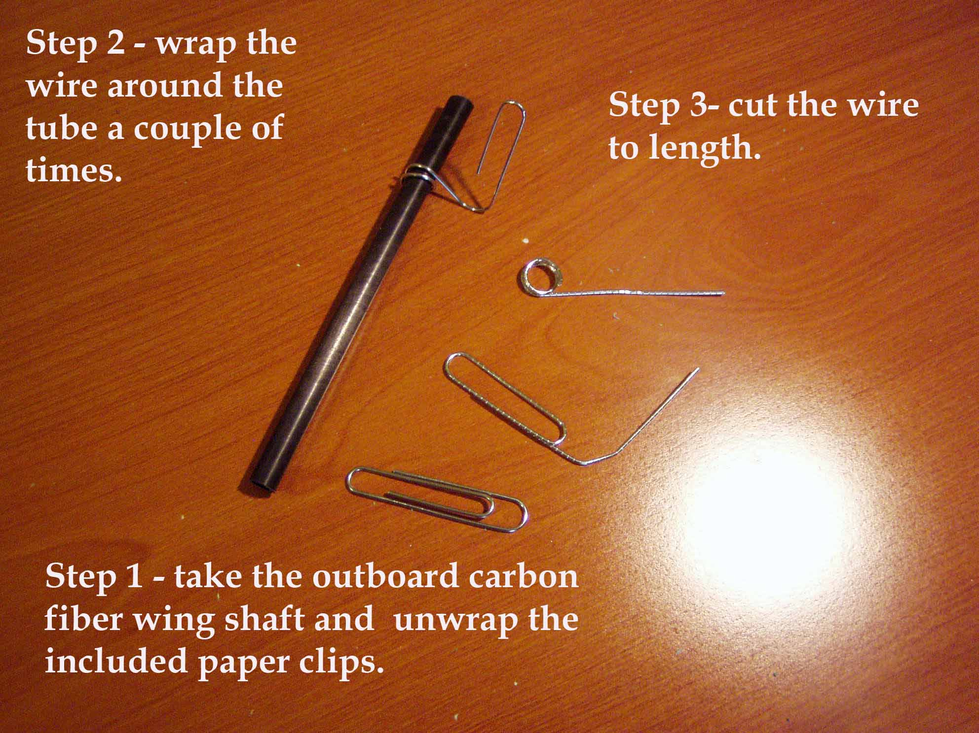
It is time to make the wire hooks that secure the outer wing panels. Straighten out the paper clips and wrap one end around one of the carbon fiber shafts a couple of times. This will make the loop seen above. Then bend the wire as shown and cut the wire as shown in the above photo.
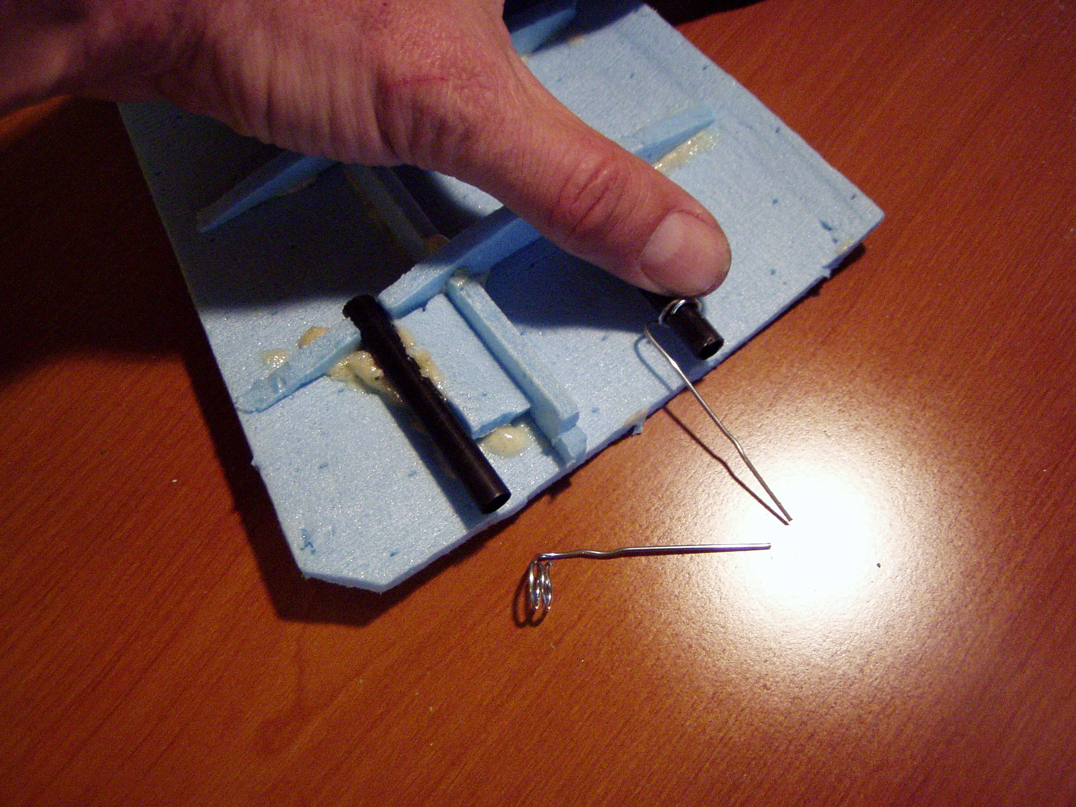
Place a right angle bend in the wire to create the part as shown and slide onto the shaft. These will be bent into hooks that will secure the wing tips.
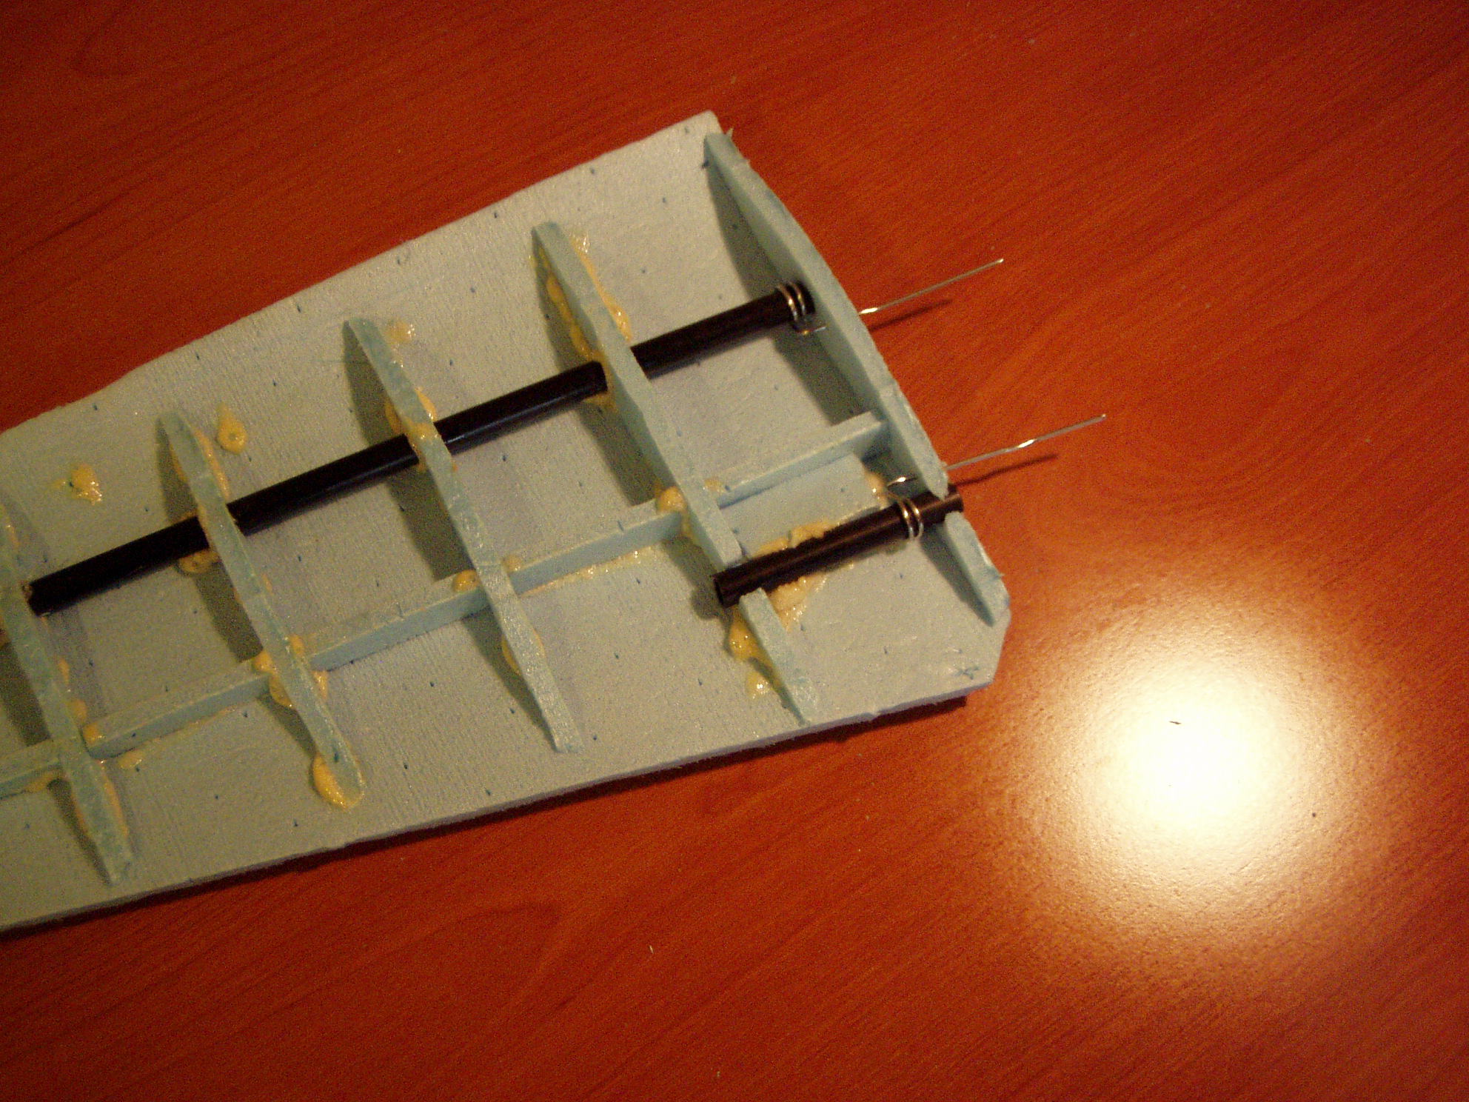
Properly positioned wing hooks, now glue them to the tubes.

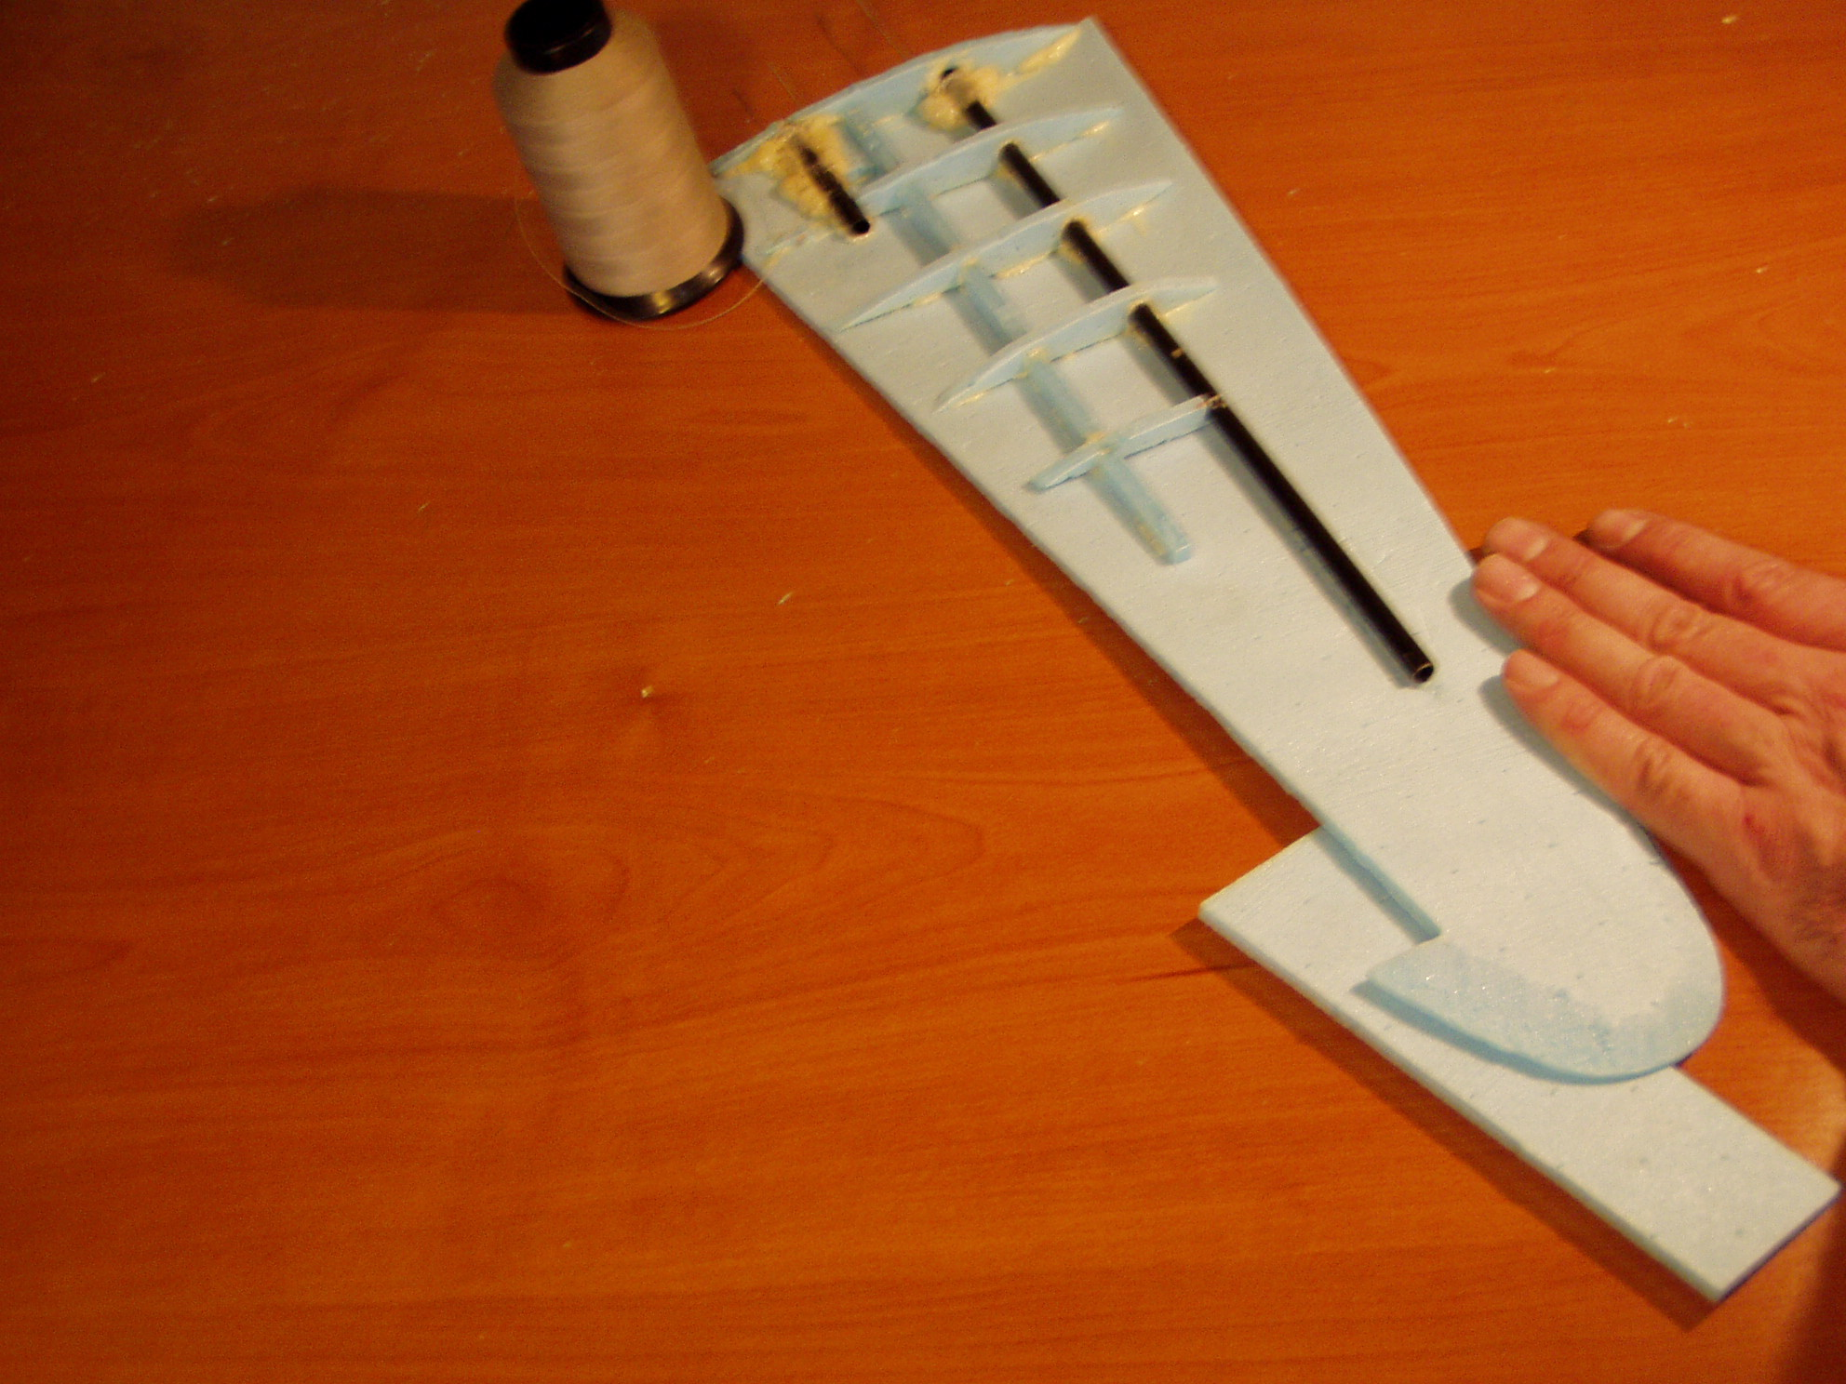
Before we glue the main spar shaft completely to the wing tip, we need to incorporate wash out. Wash out is a slight twist of a few degrees in the wing. The wing tip is twisted down a bit. This will give the wing tips a slightly smaller angle of attack than the wing root. If the airplane stalls during flight, it is dangerous for the tip portion of the wing to stall first as this can drop the aircraft into a spin.

Use a weight to press the trailing edge of the wing root to the work table and use a piece of scrap foam to put a .25” space under the trailing edge of the wing tip. Then place a weight on the leading egde of the wing tip as my hand is doing in the above photo or my thumb in the following photo. This will put the correct amount of washout in the wingtip. Now glue the main spar shaft securely in position it entire length.
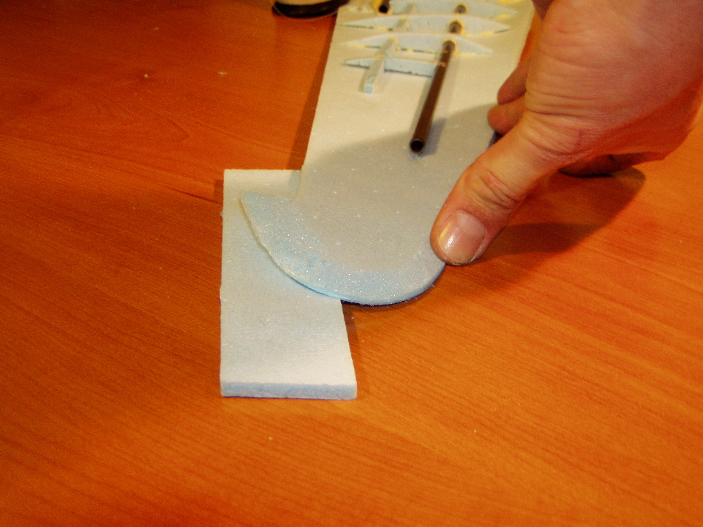

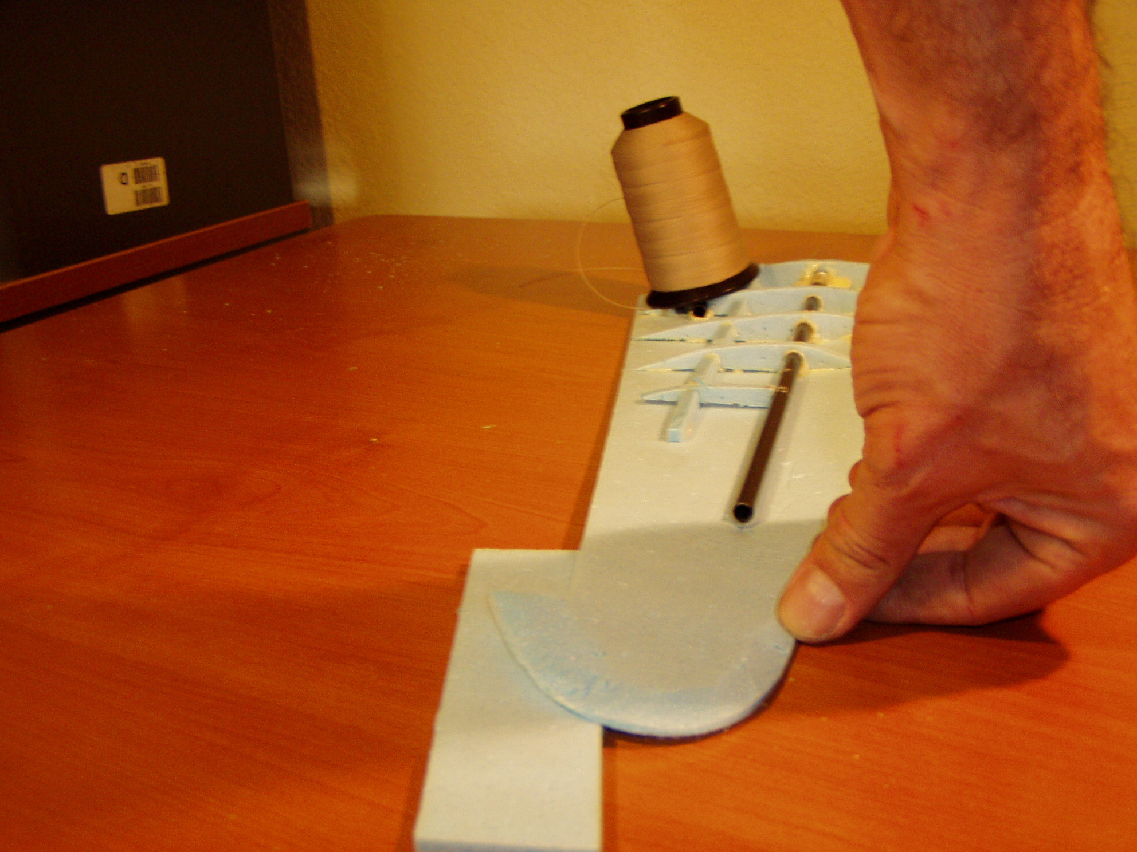
An end view of the method for creating washout.
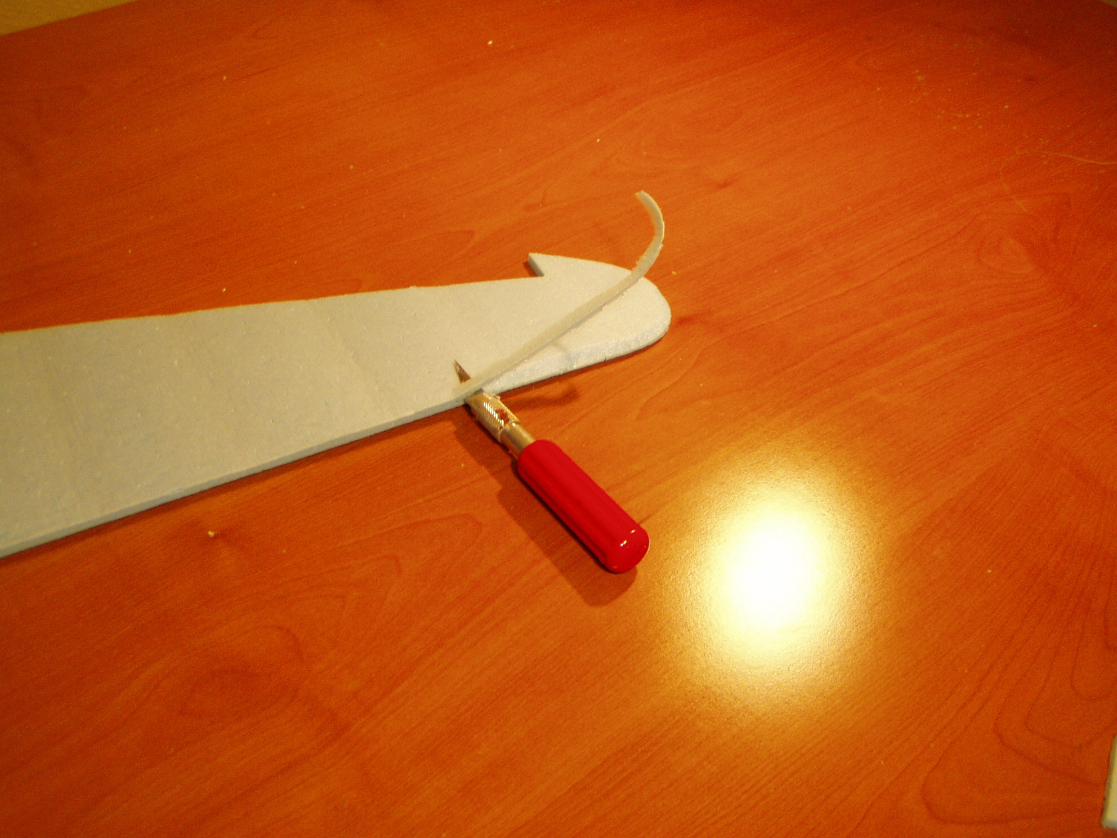
Take the wing tip, top panel and trim the inside corner of the leading edge with an exacto knife. This will give us a nice leading edge when the wing panels are joined. Cut a 45 degrees of material off as shown above and below.
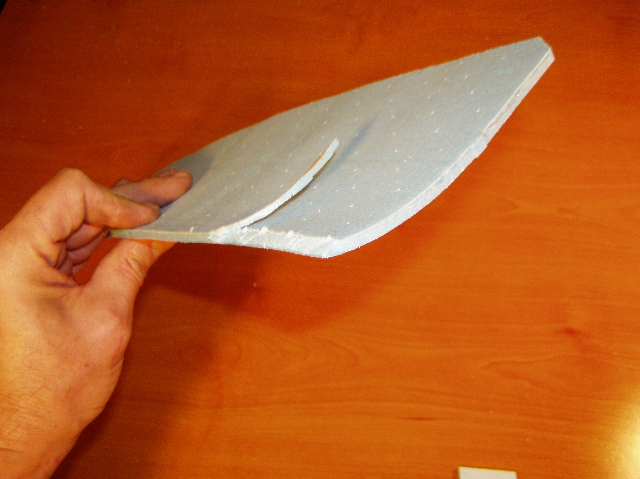
A close up of the desired leading edge trim of the top wing panel.
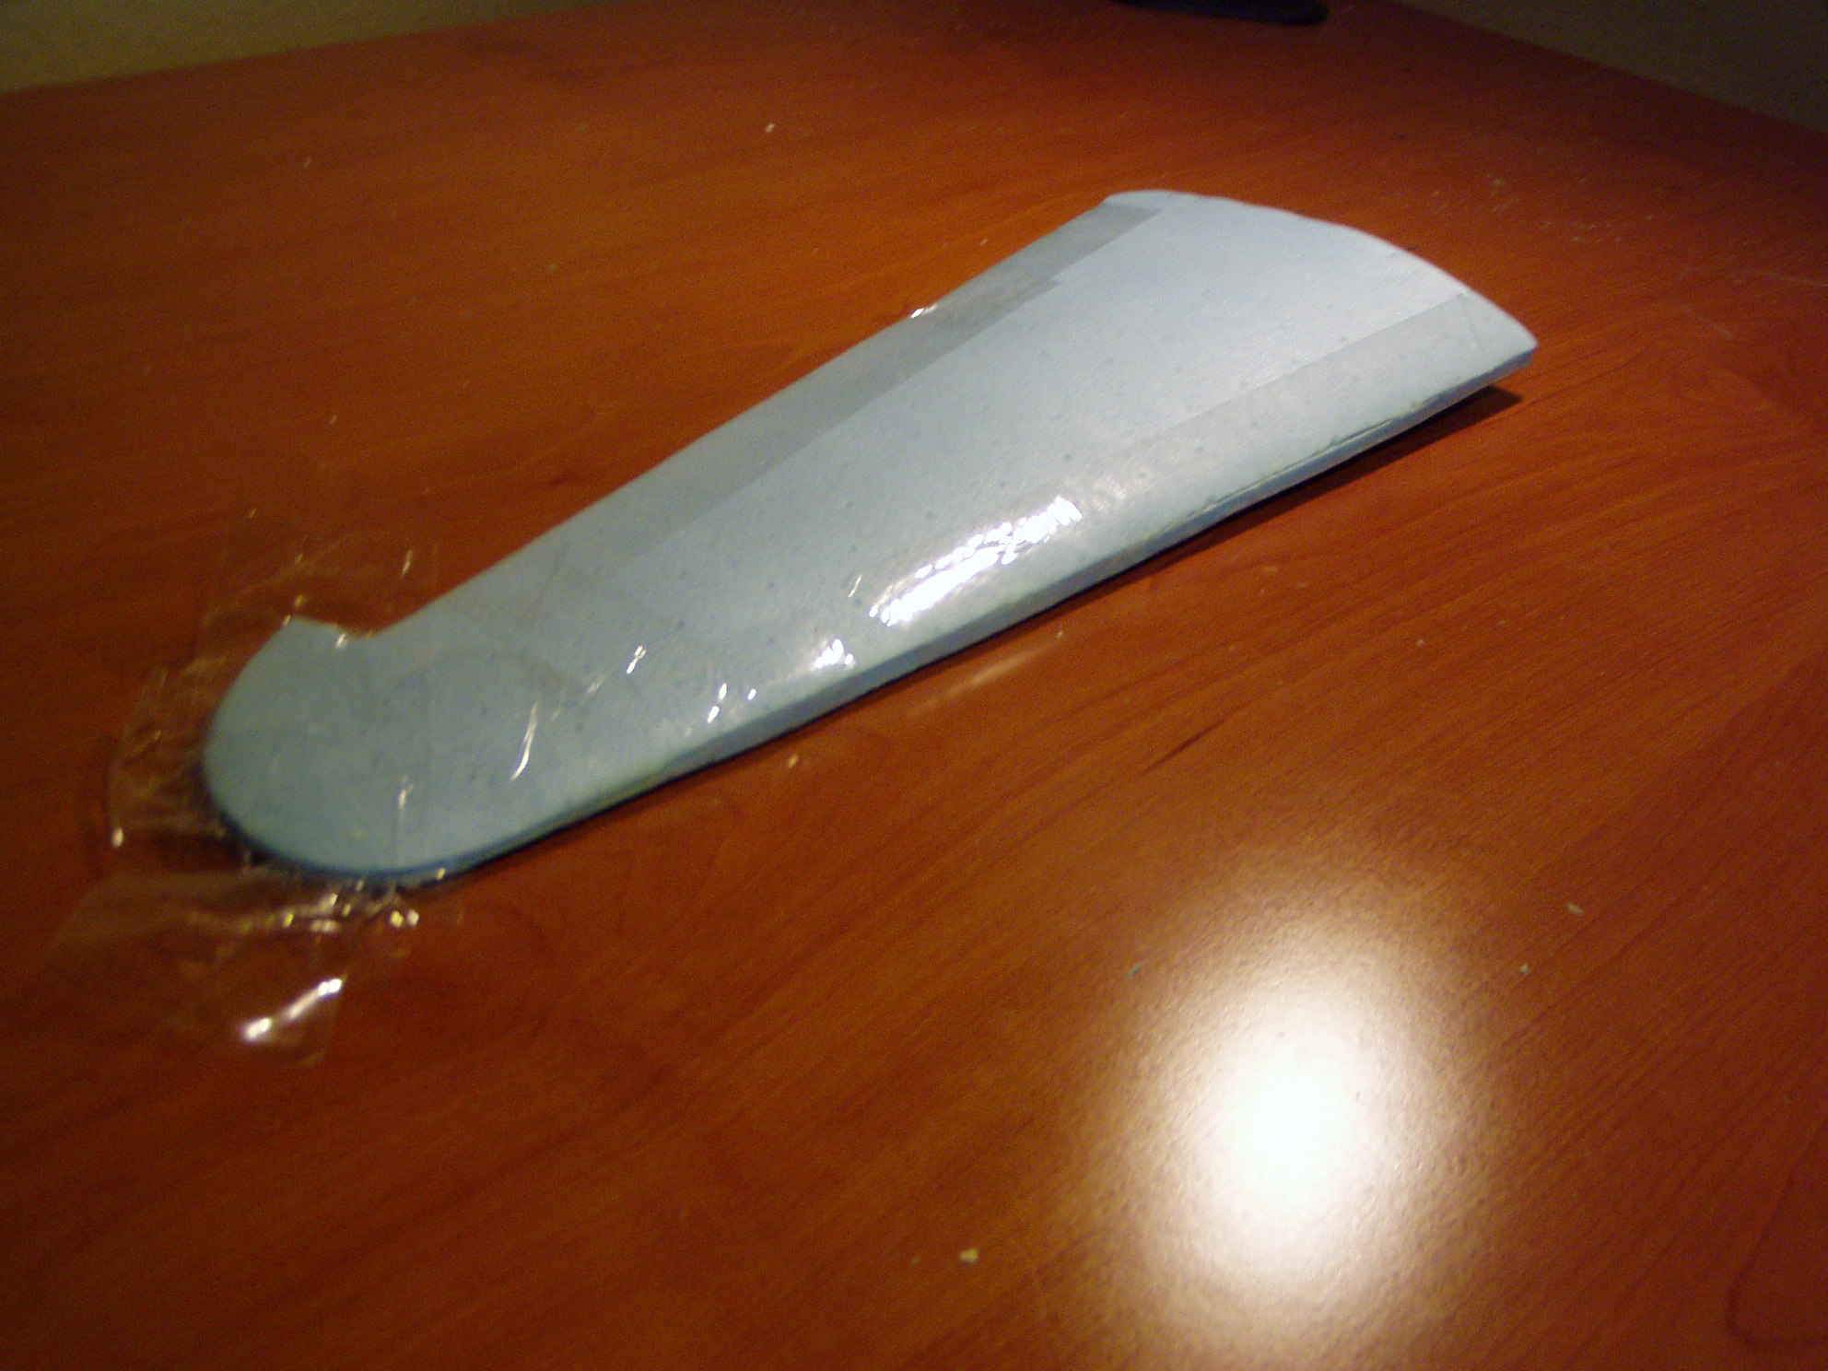
Glue the two wing panels together. I have found that using packing tape gives a very even clamping force. Before the glue has dried, insure that the wing is straight and true. Don’t let your clamping technique warp the wing in any funny way. Sight down the leading and trailing edge to make sure the wing is true.

Congratulations. This completes the construction of the wing. Next we will build the main fuselage.

